Deployment for Microsoft Office Project Portfolio Server 2007
Applies To:
Microsoft Office Project Portfolio Server 2007

Summary:
This guide describes how to install Microsoft Office Project Portfolio Server 2007 in a server farm environment and in a stand-alone environment. Deployment scenarios, including connection to Microsoft Office Project Server 2007 and Microsoft Windows SharePoint Services 3.0, are provided.
The information contained in this document represents the current view of Microsoft Corporation on the issues discussed as of the date of publication. Because Microsoft must respond to changing market conditions, it should not be interpreted to be a commitment on the part of Microsoft, and Microsoft cannot guarantee the accuracy of any information presented after the date of publication.
This document is for informational purposes only. MICROSOFT MAKES NO WARRANTIES, EXPRESS, IMPLIED OR STATUTORY, AS TO THE INFORMATION IN THIS DOCUMENT.
Complying with all applicable copyright laws is the responsibility of the user. Without limiting the rights under copyright, no part of this document may be reproduced, stored in or introduced into a retrieval system, or transmitted in any form or by any means (electronic, mechanical, photocopying, recording, or otherwise), or for any purpose, without the express written permission of Microsoft Corporation.
Microsoft may have patents, patent applications, trademarks, copyrights, or other intellectual property rights covering subject matter in this document. Except as expressly provided in any written license agreement from Microsoft, the furnishing of this document does not give you any license to these patents, trademarks, copyrights, or other intellectual property.
Unless otherwise noted, the example companies, organizations, products, domain names, e-mail addresses, logos, people, places, and events depicted herein are fictitious, and no association with any real company, organization, product, domain name, e-mail address, logo, person, place, or event is intended or should be inferred.
© 2007 Microsoft Corporation. All rights reserved.
Microsoft, ActiveX, Excel, Internet Explorer, SharePoint, Visual Basic, Windows Server, Windows Vista, and Windows are either registered trademarks or trademarks of Microsoft Corporation in the United States and/or other countries.
The names of actual companies and products mentioned herein may be the trademarks of their respective owners.

Table of Contents
Deployment for Microsoft Office Project Portfolio Server 2007 1
Table of Contents 3
Introduction 5
Overview 5
Office Project Portfolio Server 2007 Architecture Overview 6
Office Project Portfolio Server 2007 Deployment Overview 7
Office Project Server 2007 7
Windows SharePoint Services 3.0 7
Deployment Scenarios 9
Office Project Portfolio Server 2007 in a Server Farm Environment 12
Scenario 1: Server farm full deployment, including Office Project Server 2007 and Windows SharePoint Services 3.0 13
Scenario 2: Server farm deployment, including Windows SharePoint Services 3.0 16
Scenario 3: Server farm stand-alone Office Project Portfolio Server 2007 deployment 18
Office Project Portfolio Server 2007 in a Single Server Environment 20
Scenario 4: Single server full deployment, including Office Project Server 2007 and Windows SharePoint Services 3.0 21
Scenario 5: Single server deployment, including Windows SharePoint Services 3.0 23
Scenario 6: Single server stand-alone Office Project Portfolio Server 2007 deployment 24
Office Project Portfolio Server 2007 Installation 25
System Requirements for Office Project Portfolio Server 2007 26
Installation and Configuration Prerequisites 28
.NET Framework Version 2.0 28
Internet Information Services 28
SQL Server 2005 SP1 29
Windows SharePoint Services 3.0 29
Upgrading from Microsoft Office Project Portfolio Server 2006 34
Deploying Project Portfolio Server in a Distributed Workgroup Environment 35
Configuring the SQL Account 35
Installing Office Project Portfolio Server 2007 36
Installing the Office Project Portfolio Server 2007 Reporting Tier 45
Office Project Server 2007 Connection (Gateway) 51
Office Project Server 2007 Configuration Requirements 51
Project Server Gateway Setup 53
Windows SharePoint Services 3.0 Connection 58
System Configuration Tests 63
Testing Office Project Portfolio Server 2007 Services 64
Logging on to Office Project Portfolio Server 2007 66
Creating an Administrator User 68
Testing SQL Server Reporting Services Connection 70
Office Project Portfolio Server 2007 Client Installation 72
System Requirements for Project Portfolio Web Access 72
Client Computer Settings 73
Configuration for ActiveX 73
Configuration for Microsoft Visual Basic Access 78
Configuration for Windows Vista 83
Troubleshooting 85
Server Error when starting Office Project Portfolio Server 2007 86
404 File Not Found Error when starting Office Project Portfolio Server 2007 87
Case-sensitive SQL Server 87
E-mail link does not work 88
Pop-up Blocker 88
Programmatic Access to Visual Basic Project Error 88
Mass Export to Office Project Server 2007 fails 89
Appendix 91
Configuring the Installation Parameters 91
Database Server connection 92
Reporting Services connection 93
SMTP Server connection 94
Account and Permission Requirements for Server Farm Deployment Scenarios 95
Application Server to SQL Server 2005 Computer Communication 96
Application Server to Reporting Server Communication 96
Reporting Server to SQL Server 2005 Computer Communication 97
Application Server to Project Server Communication 97
Creating multiple accounts 98
Limitations 98
Recommendation 98
Enabling the Account Login Screen 98
Creating a New Account 100

Introduction

Overview
This guide describes how to install Microsoft® Office Project Portfolio Server 2007 in a distributed server farm environment and in a stand-alone environment. There is an introduction of typical deployment scenarios and a discussion of the installation process. Separate chapters describe how to link Office Project Portfolio Server 2007 with Microsoft Office Project Server 2007 and Microsoft Windows® SharePoint® Services 3.0, respectively.
A series of system configuration tests are then described, including some basic testing for the connection with Microsoft SQL Server™ 2005 Reporting Services.
The next section covers client requirements, highlighting configuration settings, followed by a discussion about more detailed configuration settings and a troubleshooting section.
In this section:
- Office Project Portfolio Server 2007 Architecture Overview
- Office Project Portfolio Server 2007 Deployment Overview

Office Project Portfolio Server 2007 Architecture Overview
Office Project Portfolio Server 2007 installation includes three main components:
- Office Project Portfolio Server 2007 application tier comprising the following components:
- Office Project Portfolio Server 2007 application: This Web-based application runs on Internet Information Services (IIS) and Microsoft ASP.NET 2.0. Some components are developed in C and C++.
- Project Portfolio Server Scheduler: This service runs at regular intervals to recalculate certain defined attributes.
- Office Project Portfolio Server 2007 database tier (SQL Server 2005 Service Pack 1 (SP1)), including the following Office Project Portfolio Server 2007 databases:
- PPSAccountIndex: This database contains information about the defined accounts in Office Project Portfolio Server 2007. Each account acts like a single instance of Office Project Portfolio Server 2007. Information cannot be shared across multiple accounts. For more information about setting up multiple accounts, see the Creating multiple accounts section of this document.
- PPSAccountData: This database contains the actual account data, such as the project, application, program and portfolio data, related cost and resource information, optimization scenarios, and other data. Even though this database can contain information from multiple accounts, we recommend having only one account per database to ease future upgrades or database migrations. For more information about setting up multiple accounts, see the Creating multiple accounts section of this document.
- Office Project Portfolio Server 2007 reporting tier (SQL Server Reporting Services), including two binary files and some configuration adjustments to a default SQL Server Reporting Services installation.

Office Project Portfolio Server 2007 Deployment Overview
A complete installation of Office Project Portfolio Server 2007 includes the three tiers previously described and requires:
- SQL Server 2005 SP1
- SQL Server Reporting Services
- Office Project Portfolio Server 2007
Each of these components can be installed on the same computer or on separate computers.
The ideal setup of these components depends on several factors, such as:
- The configuration of the Office Project Portfolio Server 2007 instance. For example, with complex cost structures, a high number of calculated attributes or complex reports can impact performance.
- The number of concurrent users.
- The types of actions performed by those users.
- Other services installed on the computer and the load on the server caused by them.
Furthermore, Office Project Portfolio Server 2007 can be linked to:
- Office Project Server 2007
- Windows SharePoint Services 3.0

Office Project Server 2007
The (optional) bidirectional gateway between Office Project Portfolio Server 2007 and Office Project Server 2007 can not only help organizations create the project inventory and select the optimal portfolio of projects, but can also help deliver projects on time, and within scope and budget. A project’s resources, activities, or plan can be managed on a detailed level in Office Project Server 2007, while rolled-up information in Office Project Portfolio Server 2007 enables portfolio reporting, analysis, and tracking.

Windows SharePoint Services 3.0
Windows SharePoint Services 3.0 can be used for document management. For each entity (project, application, program, or portfolio), attachments can be uploaded to different sites defined in Windows SharePoint Services 3.0. These attachments can be viewed through Office Project Portfolio Server 2007 or through Windows SharePoint Services 3.0 directly.

Deployment Scenarios
This section describes six scenarios. Choosing among the scenarios depends on the required optional components (Windows SharePoint Services 3.0 and Office Project Server 2007) and the load on the various servers.
The following table summarizes the recommended setup configurations based on the previous criteria.
Table 1. Deployment Scenario Recommendation
Deployment Scenario | Recommended for:
1. Server farm full deployment, including Office Project Server 2007 and Windows SharePoint Services 3.0 | Large organizations with complex configurations
2. Server farm deployment, including Windows SharePoint Services 3.0 | Large organizations with few organizational and cost levels
3. Server farm stand-alone deployment | Medium-sized organizations
4. Single server full deployment, including Office Project Server 2007 and Windows SharePoint Services 3.0 | Evaluation of Office Project Portfolio Server 2007 and its features and capabilities, including the interaction with Office Project Server 2007 and Windows SharePoint Services 3.0
5. Single server deployment, including Windows SharePoint Services 3.0 | Evaluation of Office Project Portfolio Server 2007 and its features and capabilities, including the interaction with Windows SharePoint Services 3.0 for document management
6. Single server stand-alone deployment | Evaluation of Office Project Portfolio Server 2007 and its features and capabilities, excluding document management
Each of these scenarios is described in detail on the following pages of this document.

The following table summarizes the six scenarios and the various installed components.
Table 2. Deployment Scenario Components
Scenario | Office Project Portfolio Server 2007 | SQL Server 2005 | SQL Server Reporting Services | Windows SharePoint Services 3.0 | Office Project Server 2007
1. Server farm full deployment, including Office Project Server 2007 and Windows SharePoint Services 3.0 | Server 1 | Server 2 | Server 3 | Server 4 | Server 4  (or farm server)
2. Server farm deployment, including Windows SharePoint Services 3.0 | Server 1 | Server 2 | Server 3 | Server 4
3. Server farm stand-alone deployment | Server 1 | Server 2 | Server 3
4. Single server full deployment, including Office Project Server 2007 and Windows SharePoint Services 3.0 | Server 1 | Server 1 | Server 1 | Server 1 | Server 1
5. Single server deployment, including Windows SharePoint Services 3.0 | Server 1 | Server 1 | Server 1 | Server 1
6. Single server stand-alone deployment | Server 1 | Server 1 | Server 1
The next sections describe six scenarios of deployments for Office Project Portfolio Server 2007. Scenarios 1–3 are for server farm deployments. Scenarios 4–6 are for single server deployments.
Identify the deployment scenario that most closely matches the architecture you require for your organization, and then follow the procedures in that topic to complete your installation.
The high-level steps can be followed in more detail in the Office Project Portfolio Server 2007 Installation section.
Note: For more detailed information about Office Project Server 2007 and Windows SharePoint Services 3.0 installation, see their respective deployment guides.

Office Project Portfolio Server 2007 in a Server Farm Environment
This section describes how to install Office Project Portfolio Server 2007 in a server farm environment.
In this section:
- Scenario 1: Server farm full deployment, including Office Project Server 2007 and Windows SharePoint Services 3.0
- Scenario 2: Server farm deployment, including Windows SharePoint Services 3.0
- Scenario 3: Server farm stand-alone Office Project Portfolio Server 2007 deployment
Important:
Planning your deployment carefully is crucial in a farm environment, due to its high degree of complexity. Planning your deployment allows you to gather all the information needed up front, and to determine the best deployment scenario to follow.

Scenario 1: Server farm full deployment, including Office Project Server 2007 and Windows SharePoint Services 3.0
This setup is the most scalable solution and supports the most concurrent users. It also supports integration between Office Project Portfolio Server 2007 and Office Project Server 2007.

Recommendation
Office Project Portfolio Server 2007 in full server topology can be used by large organizations.

Architecture Overview
The deployment consists of:
- A dedicated computer for Office Project Portfolio Server 2007.
- A dedicated computer running SQL Server Reporting Services.
- A dedicated computer for Office Project Server 2007 and Windows SharePoint Services 3.0.
- A shared computer running SQL Server 2005 for Office Project Portfolio Server 2007, Office Project Server 2007, Windows SharePoint Services 3.0, and SQL Server Reporting Services.
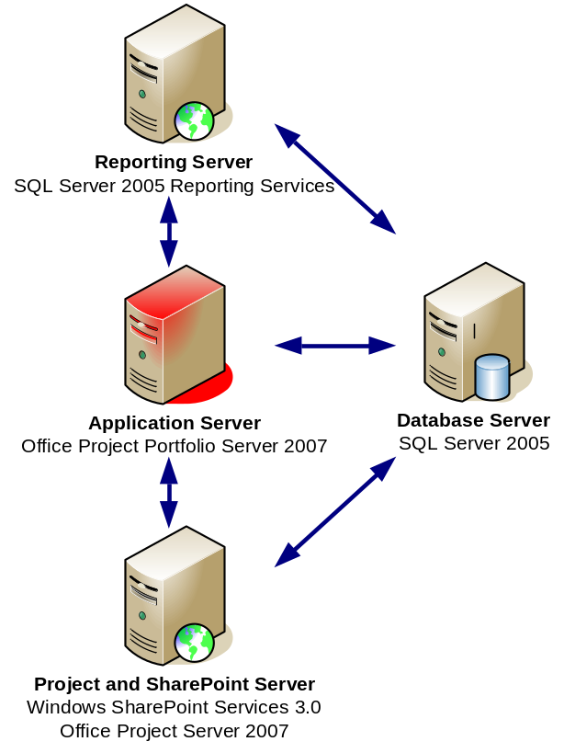
Figure 1. Server farm full deployment, including Office Project Server 2007 and Windows SharePoint Services 3.0
Office Project Portfolio Server 2007 in a full farm deployment is characterized by a three-tiered configuration. The application tier, database tier, and reporting tier are all installed on separate computers. The database tier can be shared with the database tiers of Office Project Server 2007 and Windows SharePoint Services 3.0. To increase performance, separate computers running SQL Server 2005 can be installed for each component.
Furthermore, the application tier of Office Project Server 2007 and Windows SharePoint Services 3.0 is installed on the fourth server.
Note: Office Project Server 2007 can also be installed on a farm server environment, and then linked to Office Project Portfolio Server 2007.
For more information about deploying Office Project Server 2007 and Windows SharePoint Services 3.0, see their respective deployment guides.

Installation Roadmap
Installing Office Project Portfolio Server 2007 in a full farm deployment requires completion of the following steps. Before starting the steps for the application server, perform the sequence of steps for the database and reporting tiers.
- Install SQL Server 2005 SP1.
- Install SQL Server Reporting Services.
- Install Office Project Server 2007 with Windows SharePoint Services 3.0.
- Install Office Project Portfolio Server 2007.
Note: The order of steps 3 and 4 can be changed.
The SQL Server Reporting Services component can be installed on a computer running SQL Server 2005. However, in case complex calculation-intensive reports are generated in Office Project Portfolio Server 2007, it is recommended that you install this component on a separate computer.

Scenario 2: Server farm deployment, including Windows SharePoint Services 3.0
This setup is similar to scenario 1 but it excludes the linkage with Office Project Server 2007, which can be installed at a later stage.

Recommendation
This deployment can be used by large organizations.

Architecture Overview
The deployment consists of:
- A dedicated computer for Office Project Portfolio Server 2007.
- A dedicated computer running SQL Server Reporting Services.
- A dedicated computer for Windows SharePoint Services 3.0.
- A shared computer running SQL Server 2005 for Office Project Portfolio Server 2007, Windows SharePoint Services 3.0, and SQL Server Reporting Services.
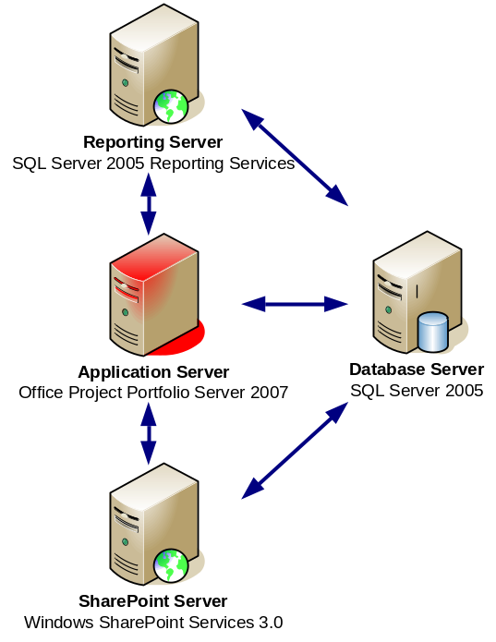
Figure 2. Server farm deployments, including Windows SharePoint Services 3.0
This deployment is characterized by a three-tiered configuration. The application tier, database tier, and reporting tier are all installed on separate computers. The database tier can be shared with the database tiers of SQL Server Reporting Services and Windows SharePoint Services 3.0.
Furthermore, the application tier of Windows SharePoint Services 3.0 is installed on a fourth server. For more information about deploying Windows SharePoint Services 3.0, see its deployment guide.

Installation Roadmap
Installing Office Project Portfolio Server 2007 in a server farm deployment requires completion of the following steps. Before starting the steps for the application server, perform the sequence of steps for the database and reporting tiers.
- Install SQL Server 2005 SP1.
- Install SQL Server Reporting Services.
- Install Windows SharePoint Services 3.0.
- Install Office Project Portfolio Server 2007.
Note: The order of steps 3 and 4 can be changed.
The SQL Server Reporting Services component can be installed on a computer running SQL Server 2005. However, if complex calculation-intensive reports need to be generated, it is recommended that you install this component on a separate computer.

Scenario 3: Server farm stand-alone Office Project Portfolio Server 2007 deployment
This setup is similar to scenario 1 but it excludes the linkage with both Office Project Server 2007 and Windows SharePoint Services 3.0. Both components can be installed at a later stage.

Recommendation
This deployment can be used by large organizations not requiring document management through Office Project Portfolio Server 2007.

Architecture Overview
The deployment consists of:
- A dedicated computer for Office Project Portfolio Server 2007.
- A dedicated computer running SQL Server Reporting Services.
- A shared computer running SQL Server 2005 for Office Project Portfolio Server 2007 and SQL Server Reporting Services.
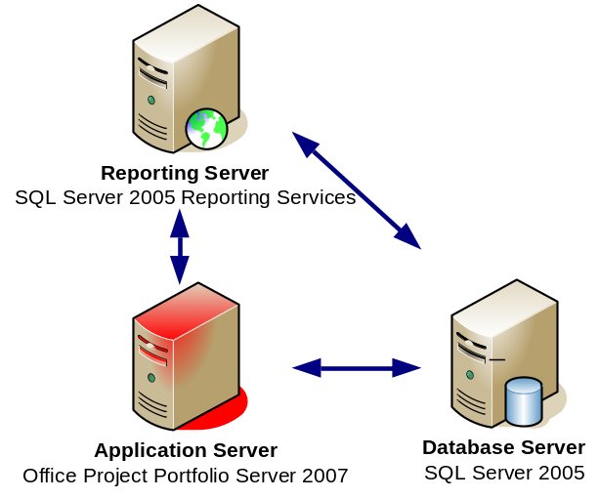
Figure 3. Server farm stand-alone deployment
This deployment is characterized by a three-tiered configuration. The application tier, database tier, and reporting tier are all installed on separate computers. The database tier can be shared with the database tier of SQL Server Reporting Services.

Installation Roadmap
This deployment requires completion of the following steps. Before starting the steps for the application server, perform the sequence of steps for the database and reporting tiers.
- Install SQL Server 2005 SP1.
- Install SQL Server Reporting Services.
- Install Office Project Portfolio Server 2007.
The SQL Server Reporting Services component can be installed on a computer running SQL Server 2005, requiring only two servers in total. However, in case complex calculation-intensive reports are generated in Office Project Portfolio Server 2007, it is recommended that you install this component on a separate computer.

Office Project Portfolio Server 2007 in a Single Server Environment
This section describes how to install Office Project Portfolio Server 2007 in single server environment.
In this section:
- Scenario 4: Single server full deployment, including Office Project Server 2007 and Windows SharePoint Services 3.0
- Scenario 5: Single server deployment, including Windows SharePoint Services 3.0
- Scenario 6: Single server stand-alone Office Project Portfolio Server 2007 deployment

Scenario 4: Single server full deployment, including Office Project Server 2007 and Windows SharePoint Services 3.0
Office Project Portfolio Server 2007 can also be installed on a single computer, including Windows SharePoint Services 3.0 for document management within Office Project Portfolio Server 2007.
This setup requires a shared computer for Office Project Portfolio Server 2007, Windows SharePoint Services 3.0, SQL Server 2005, and SQL Server Reporting Services.
Important:
Note the following limitation of the stand-alone mode version of Office Project Server 2007: Windows SharePoint Services 3.0 cannot be installed on the same Web site as Office Project Portfolio Server 2007; see page 30.

Recommendation
Single server mode is useful if you want to evaluate Office Project Portfolio Server 2007 with its features and capabilities, including the interaction with Office Project Server 2007 and Windows SharePoint Services 3.0.

Architecture Overview
This setup is composed of a single, shared computer for Office Project Portfolio Server 2007, Office Project Server 2007, Windows SharePoint Services 3.0, SQL Server 2005, and SQL Server Reporting Services.
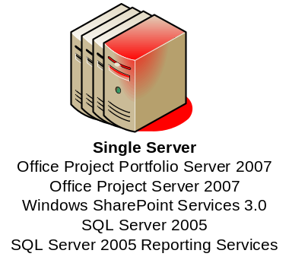
Figure 4. Single server full deployment, including Office Project Server 2007 and Windows SharePoint Services 3.0

Installation Roadmap
Installing Office Project Portfolio Server 2007 in a single server full deployment scenario requires completion of the following steps. Before starting the steps for the application server, perform the sequence of steps for the database and reporting tiers.
- Install SQL Server 2005 SP1 and SQL Server Reporting Services.
- Install Office Project Server 2007 with Windows SharePoint Services 3.0.
- Install Office Project Portfolio Server 2007 on a separate Web site.
Note: The order of steps 2 and 3 can be changed.

Scenario 5: Single server deployment, including Windows SharePoint Services 3.0
Office Project Portfolio Server 2007 can be installed on a single computer, including Windows SharePoint Services 3.0 for document management within Office Project Portfolio Server 2007.

Recommendation
Single server mode is useful if you want to evaluate Office Project Portfolio Server 2007 and its features and capabilities, including the interaction with Windows SharePoint Services 3.0 for document management.

Architecture Overview
This setup requires a shared computer for Office Project Portfolio Server 2007, Windows SharePoint Services 3.0, SQL Server 2005, and SQL Server Reporting Services.
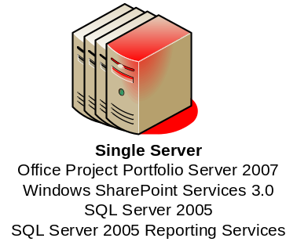
Figure 5. Single server full deployment, including Windows SharePoint Services 3.0

Installation Roadmap
Installing Office Project Portfolio Server 2007 in a single server deployment scenario requires completion of the following steps. Before starting the steps for the application server, perform the sequence of steps for the database and reporting tiers.
- Install SQL Server 2005 SP1 and SQL Server Reporting Services.
- Install Windows SharePoint Services 3.0.
- Install Office Project Portfolio Server 2007 on a separate Web site.
Note: The order of steps 2 and 3 can be changed.

Scenario 6: Single server stand-alone Office Project Portfolio Server 2007 deployment
Office Project Portfolio Server 2007 can be installed on a single computer in stand-alone mode. In stand-alone mode, the application server, the reporting server, and the database are all installed on a single computer by using default settings.

Recommendation
Single server stand-alone deployment is useful if you want to evaluate Office Project Portfolio Server 2007 and its features and capabilities, excluding document management.

Architecture Overview
This setup is a single-computer solution for Office Project Portfolio Server 2007, SQL Server 2005, and SQL Server Reporting Services.
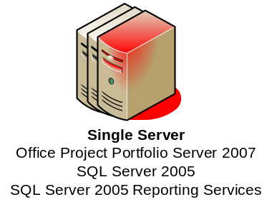
Figure 6. Single server stand-alone deployment

Installation Roadmap
Installing Office Project Portfolio Server 2007 in a single server deployment scenario requires completion of the following steps. Before starting the steps for the application server, perform the sequence of steps for the database and reporting tiers.
- Install SQL Server 2005 SP1 and SQL Server Reporting Services.
- Install Office Project Portfolio Server 2007.

Office Project Portfolio Server 2007 Installation
This section describes the procedures required to install Office Project Portfolio Server 2007 on a computer. Use these procedures in conjunction with the chosen installation roadmap in the Deployment Scenarios section of this document.
In this section:
- System Requirements for Office Project Portfolio Server 2007
- Installation and Configuration Prerequisites
- Upgrading from Microsoft Office Project Portfolio Server 2006
- Deploying Project Portfolio Server in a Distributed Workgroup Environment
- Installing Office Project Portfolio Server 2007
- Installing the Office Project Portfolio Server 2007 Reporting Tier

System Requirements for Office Project Portfolio Server 2007
The processor, RAM, and hard disk requirements for Office Project Portfolio Server 2007 are highly dependent on the configuration of the Office Project Portfolio Server 2007 instance, the number of concurrent users, the types of actions required by the users, and the number of services installed on the server.
The following table summarizes the minimum requirements for running Office Project Portfolio Server 2007.
Table 3. System Requirements for Office Project Portfolio Server 2007
Component | Requirement
Operating system | Microsoft Windows Server® 2003 SP1 (32-bit)
Single computer installation | Server with a minimum 2.5 gigahertz (GHz) processor; minimum of 1 gigabyte (GB) of RAM, 2 GB recommended; 1 GB of available hard disk space for installation  Server running SQL Server 2005 SP1 with a minimum 2.5 GHz processor; minimum of 2 GB of RAM
Drive | CD-ROM or DVD drive
Display | Minimum 800 × 600; 1024 × 768 or higher-resolution monitor recommended
Browser | Microsoft Internet Explorer® 6.0 with service packs or Windows Internet Explorer 7, 32-bit browser version
Network connection | 100 megabits per second (Mbps) connection speed is required to utilize Office Project Portfolio Server 2007 functionality.
Other requirements | Microsoft .NET Framework version 2.0; IIS 6.0; ASP.NET 2.0
Additional components | Processor, RAM, and hard-disk requirements for Office Project Portfolio Server 2007 are highly dependent on the number of services installed on the computer and the load on the server.  SQL Server Reporting Services (included with SQL Server 2005) is required for reporting.  Office Project Server 2007 is required to use the Project Server Gateway (the bidirectional link between Office Project Portfolio Server 2007 and Office Project Server 2007).  Windows SharePoint Services 3.0 (included in Windows Server 2003) is required for document management.

Installation and Configuration Prerequisites
This section provides the steps required to successfully install Office Project Portfolio Server 2007. This information assumes that you have already installed Windows Server 2003 SP1.

.NET Framework Version 2.0
Office Project Portfolio Server 2007 is built on top of the .NET Framework. Before installing the Office Project Portfolio Server 2007 Web component, ensure the .NET Framework version 2.0 is installed on the Office Project Portfolio Server 2007 application server.
Download and install the .NET Framework version 2.0 Redistributable Package (x86) from the following location and follow the setup instructions available on the download page: http://www.microsoft.com/downloads/details.aspx?familyid=0856eacb-4362-4b0d-8edd-aab15c5e04f5&displaylang=en

Internet Information Services
Office Project Portfolio Server 2007 is a Web-based tool that runs with Internet Information Services (IIS). Before installing Office Project Portfolio Server 2007, make sure the IIS Windows component is installed on the computer.
To install the IIS Windows component, perform the following steps:
- Click Start, and then click Manage Your Server.
- On the Manage Your Server page, click Add or remove a role.
- In the Preliminary Steps pane, click Next.
- In the Server Role pane, click Application server, and then click Next.
- In the Application Server Options pane, ensure Internet Information Services (IIS) is checked, and then click Next.
Note: You do not have to check Enable ASP.NET because this will install the 1.1 version of the .NET Framework. Ensure the .NET Framework version 2.0 is installed by following the instruction in the .NET Framework Version 2.0 section of this document.
- On the Summary of Selections page, click Next.
- Click Finish.
Note: It is recommended that you configure IIS to use Secure Sockets Layer (SSL) for best security. For more information about configuring IIS to use SSL, see your IIS documentation.

SQL Server 2005 SP1
Office Project Portfolio Server 2007 requires SQL Server 2005 SP1. Ensure that SQL Server 2005 is properly installed prior to continuing the setup, and that the following components have been installed:
- SQL Server Database Services
- SQL Server Reporting Services (can be installed on a different computer; see the Deployment Scenarios section of this document)
- Workstation components, Books Online, and development tools
The instructions on the systems requirements, installation, and setup information for SQL Server 2005 can be found in Microsoft SQL Server 2005 Books Online, which can be found at http://www.microsoft.com/downloads/details.aspx?familyid=BE6A2C5D-00DF-4220-B133-29C1E0B6585F&displaylang=en.
Note: Office Project Portfolio Server 2007 supports computers running SQL Server 2005 configured by using Windows authentication (recommended) or SQL authentication. The SQL authentication mode can be modified anytime after the installation of SQL Server 2005.

Windows SharePoint Services 3.0
Windows SharePoint Services 3.0 and Office Project Portfolio Server 2007 cannot be installed on the same Web site.
If you plan to use the same computer for both products, install Windows SharePoint Services 3.0 first by using the default Web site. Then create a new Web site to install Office Project Portfolio Server 2007 application files by performing the following steps.
Note: The following steps only need to be performed if Windows SharePoint Services 3.0 is installed on the same computer as Office Project Portfolio Server 2007.
- Create a directory named C:\PortfolioServer2007 in your root folder.
- Open IIS Manager.
- Expand IIS Manager to Web Sites. Right-click Web Sites, point to New, and then click Web Site.
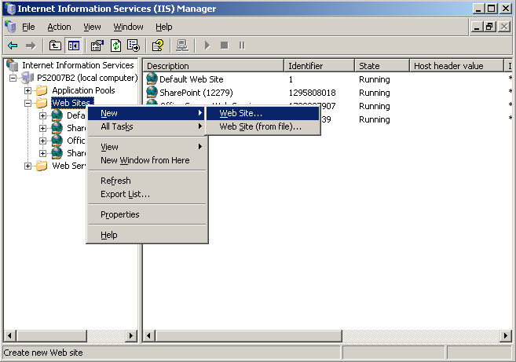
Figure 7. Internet Information Services (IIS) Manager
- On the Web Site Creation Wizard, click Next.
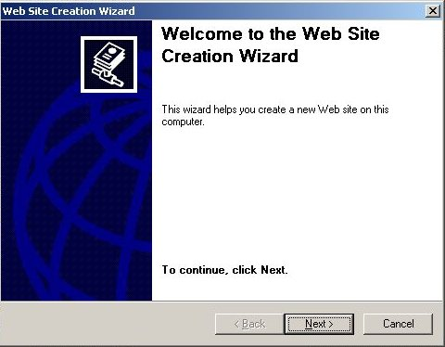
Figure 8. Web Site Creation Wizard
- In the Description box, type Project Portfolio Server 2007, and then click Next.
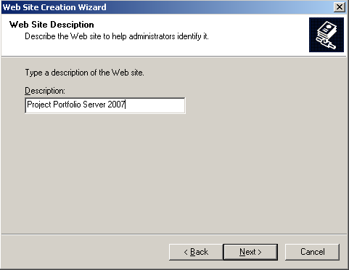
Figure 9. Web Site Creation Wizard — Web Site Description
- Create a Web site different from the default Web site by changing one of the following: the IP address, the TCP port number, or the host header. For example, you can use 81 as your port number.
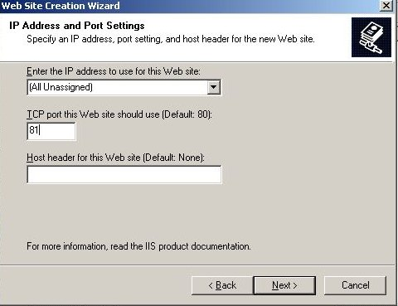
Figure 10. Web Site Creation Wizard — IP Address and Port Settings
- Browse to the directory in which you want the application installed, clear the Allow anonymous access to this Web site check box, and then click Next.
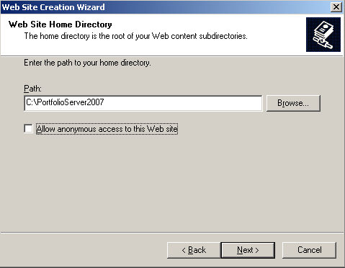
Figure 11. Web Site Creation Wizard — Web Site Home Directory
- Select the Read and Run scripts (such as ASP) check boxes, click Next, and then close the wizard.
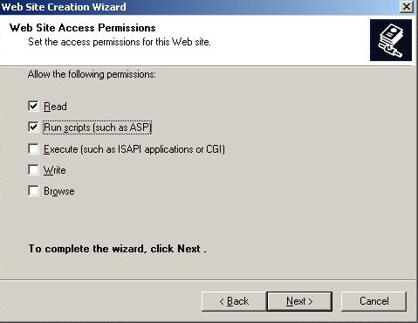
Figure 12. Web Site Creation Wizard — Web Site Access Permissions

Upgrading from Microsoft Office Project Portfolio Server 2006
Upgrading from Microsoft Office Project Portfolio Server 2006 to Office Project Portfolio Server 2007 is not supported. In addition, Office Project Portfolio Server 2007 cannot be installed on the same computer as Office Project Portfolio Server 2006.
If Office Project Portfolio Server 2007 must be installed on a server where Office Project Portfolio Server 2006 is currently installed, Office Project Portfolio Server 2006 must first be uninstalled by performing the following steps:
- Remove the virtual directory created for Office Project Portfolio Server 2006.
- Uninstall the Office Project Portfolio Server 2006 Scheduler.
- Undo the changes made to the reporting server’s configuration files.
Note: The databases for Office Project Portfolio Server 2006 are not compatible with those for Office Project Portfolio Server 2007. To migrate older databases to Office Project Portfolio Server 2007, see the Microsoft Office Project Portfolio Server 2007 Programmer Reference (http://www.microsoft.com/downloads/details.aspx?FamilyId=18848D8B-6784-4E6A-B716-96D571EEB676&displaylang=en).

Deploying Project Portfolio Server in a Distributed Workgroup Environment
SQL authentication and Windows authentication mode must be enabled before installing Office Project Portfolio Server 2007 in a distributed workgroup environment.

Configuring the SQL Account
- Ensure SQL authentication is enabled on the computer running SQL Server 2005.
- Connect to the computer running SQL Server 2005 by using SQL Server 2005 Management Studio.
- In the Object Explorer window, right-click the name of the SQL Server computer and choose Properties.
- Navigate to the Security page, and under Server Authentication ensure that SQL authentication and Windows authentication are selected.
- Create a dedicated SQL account to be used by Office Project Portfolio Server 2007. The permissions required for this account will depend on whether a new database will be created, or you will connect to an existing database.
- When a new database will be created, the SQL account used by Office Project Portfolio Server 2007 will require db_creator and db_securityAdmin permissions.
- When connecting Office Project Portfolio Server 2007 to an existing database, the SQL account used by Office Project Portfolio Server 2007 will require db_datareader and db_datawriter permissions to the Office Project Portfolio Server 2007 databases.
- On the Database connection information screen of the Office Project Portfolio Server 2007 installation wizard, select SQL authentication from the Database Authentication options. The account information will be written to the Web.config file and used to allow the Office Project Portfolio Server 2007 application server to communicate with the remote computer running SQL Server 2005. For more information, see the Configuring the Installation Parameters section in the Appendix of this document.
Note: When using SQL authentication, the Grant rights to control on the Database connection information screen in the Office Project Portfolio Server 2007 installation wizard will be ignored.

Installing Office Project Portfolio Server 2007
This section details the steps needed to install the application and database tiers of Office Project Portfolio Server 2007, if SQL Server Reporting Services is installed on different computer from Office Project Portfolio Server 2007 (see scenarios 1–3).
To install Office Project Portfolio Server 2007:
- Open IIS Manager.
- Click Web Service Extensions.
- Set ASP.NET 2.0 to Allow in the list of IIS Web Server Extensions.
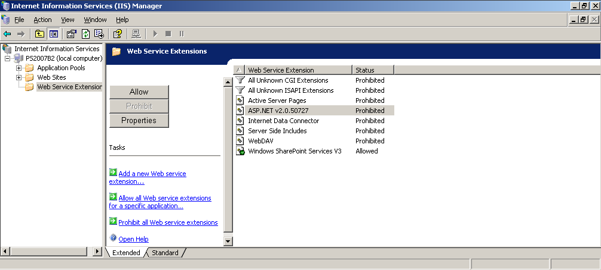
Figure 13. IIS Manager — Web Service Extensions
- From the Office Project Portfolio Server 2007 installation CD, start the PPS.MSI Installer. Click Next.
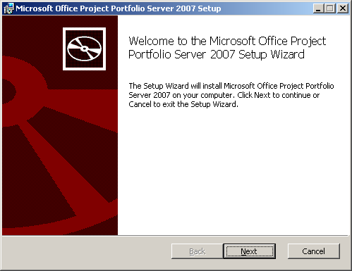
Figure 14. Microsoft Office Project Portfolio Server 2007 Setup Wizard
- Review the license terms. If you accept the terms, select the corresponding box, and click Next.
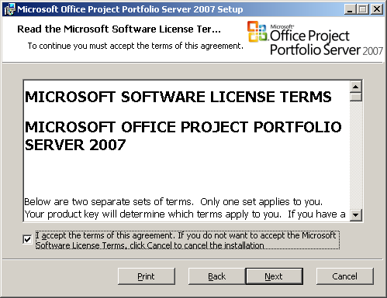
Figure 15. Microsoft Office Project Portfolio Server 2007 Setup — Microsoft Software License Terms
- Enter the 25-character Product Key that came with the Office Project Portfolio Server 2007 installation CD, and click Next.
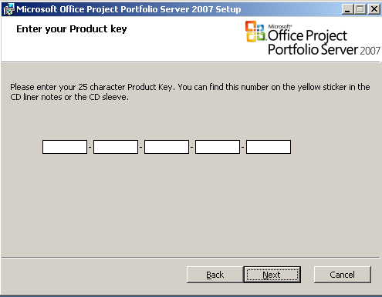
Figure 16. Microsoft Office Project Portfolio Server 2007 Setup — Enter your Product key
- Select the Site under which you want to install Office Project Portfolio Server 2007. Type PortfolioServer as the name for the virtual directory that will be created to install Office Project Portfolio Server 2007, and click Next.
Note: Do not use Default Web Site if you have Windows SharePoint Services 3.0 installed on that Web site. Choose Project Portfolio Server 2007, the name of the Web site you created in step 5 on page 33.
The chosen Virtual Directory will be shown in the URL when you start the application. Typically, the login URL will either be http://servername/VirtualDirectory (non-SSL) or https://servername/VirtualDirectory (SSL).
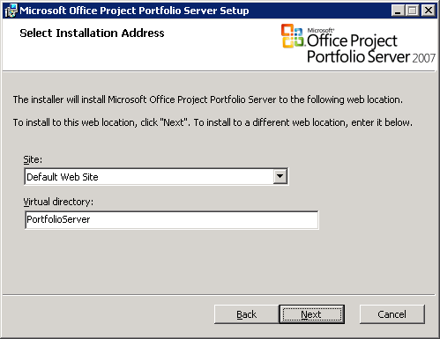
Figure 17. Microsoft Office Project Portfolio Server 2007 Setup — Select Installation Address
- Select the features you want to install, and click Next.
- Web Site contains the application part of Office Project Portfolio Server 2007. Check if the location is a valid location and consists of the Web site home location\virtual directory chosen previously.
- Scheduler Service contains the Office Project Portfolio Server Scheduler. This service will update cached values on a regular basis and is usually installed on the same computer as the Office Project Portfolio Server 2007 application.
Note: This component is required for proper functionality of Office Project Portfolio Server 2007. For security purposes, the Scheduler Service should not be installed in a directory accessible through an IIS Web site or virtual directory. Select the Scheduler Service component on the Advanced Configuration screen, and click the Browse button to set a location that is different from the Web site component location.
- Reporting Services configuration contains the standard reports and configuration changes necessary for Office Project Portfolio Server 2007 to run reports. If you have SQL Server Reporting Services installed on the same computer as Office Project Portfolio Server 2007 (see scenarios 4–6), set the feature to install, and then browse to the Reporting Services installation location, typically located under C:\Program Files\Microsoft SQL Server\MSSQL.instance\Reporting Services\ReportServer. Do not select the subcomponent “Portfolio Component.”
- Portfolio Component contains necessary binaries of Office Project Portfolio Server 2007 to be installed on a remote reporting server that has SQL Server Reporting Services installed (see scenarios 1–3). Do not select this component if you have also selected the Web Site component.
Note: If you have installed SQL Server Reporting Services on a separate computer, rerun the Office Project Portfolio Server 2007 Installer on the computer running SQL Server Reporting Services, and select Reporting Services configuration and all subcomponents. For more information, see the Installing the Office Project Portfolio Server 2007 Reporting Tier section on page 46.
Important:
If you have SQL Server Reporting Services installed on the same computer as Office Project Portfolio Server 2007 (see scenarios 4–6), set the feature to install and then browse to the SQL Server Reporting Services installation location, typically located under C:\Program Files\Microsoft SQL Server\MSSQL.instance\Reporting Services\ReportServer. Do not select the subcomponent “Portfolio Component.” Failure to browse to the correct path will result in a failure to install Office Project Portfolio Server 2007.
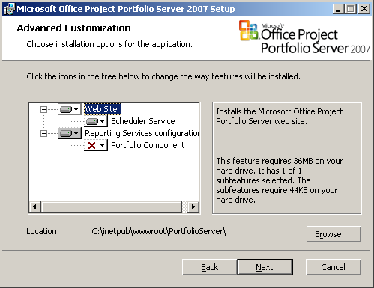
Figure 18. Microsoft Office Project Portfolio Server 2007 Setup — Advanced Customization
- Specify the Primary Database server on which Office Project Portfolio Server 2007 databases should be installed. For an initial installation, select Create new databases and use Integrated Windows authentication or SQL authentication to connect to the database server. Click Next.
Note: The Windows user account specified in the Grant rights to text box will be granted db_datareader and db_datawriter permissions to the Office Project Portfolio Server 2007 databases when the Create new databases option is selected. The application pool used for the Office Project Portfolio Server 2007 site must have an identity configured that has db_datareader and db_datawriter permissions on the Office Project Portfolio Server 2007 databases for communication to work between the computer running SQL Server 2005 and the Office Project Portfolio Server 2007 application server. For more information about security permissions required in a distributed environment, see the Account and Permission Requirements for Server Farm Deployment Scenarios section in the Appendix of this document.
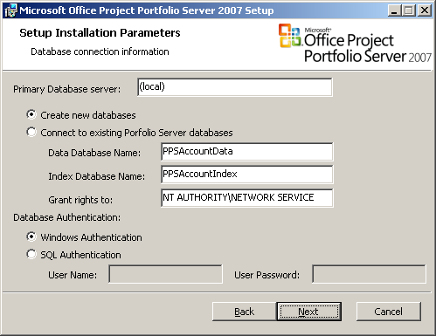
Figure 19. Microsoft Office Project Portfolio Server 2007 Setup — Setup Installation Parameters, Database connection information
Selecting Create new database requires that the account used for database authentication have db_creator and db_securityAdmin permissions on the computer running SQL Server 2005.
Selecting Connect to existing Portfolio Server databases requires that the account used for database authentication have db_datareader and db_datawriter permissions to the existing Data and Index Office Project Portfolio Server databases.
For more information about security permissions required in a distributed environment, see the Account and Permission Requirements for Server Farm Deployment Scenarios in the Appendix of this document.
Note: Similar databases for previous releases of Office Project Portfolio Server (3.3 or 2006) are not compatible and need to be upgraded. For more information, see the Microsoft Office Project Portfolio Server 2007 Programmer Reference (http://www.microsoft.com/downloads/details.aspx?FamilyId=18848D8B-6784-4E6A-B716-96D571EEB676&displaylang=en).
Note: Office Project Portfolio Server 2007 does not support case-sensitive deployments of SQL Server 2005.
- In the Reporting Parameters and SMTP information page, specify the Reporting Services URL. If you installed SQL Server Reporting Services on the same computer, this would be http://localhost/ReportServer/.
- Specify the Reports Folder in which all Office Project Portfolio Server 2007 reports will be saved (default “/Reports”).
- Specify the SMTP Server used for sending e-mail messages. This server should be reachable on the default SMTP port 25 from the Office Project Portfolio Server 2007 application server.
Note: Office Project Portfolio Server 2007 will not function properly with SMTP servers that require authentication.
- Specify the e-mail From Address that should be used as the originating e-mail address for notifications sent by Office Project Portfolio Server 2007. Click Next.
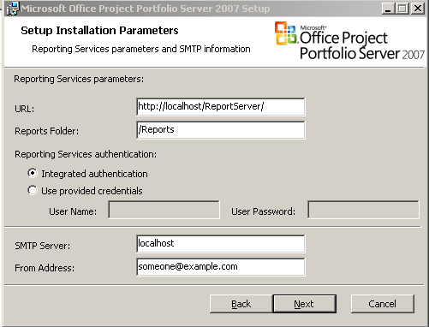
Figure 20. Microsoft Office Project Portfolio Server 2007 Setup — Setup Installation Parameters, Reporting Services parameters and SMTP information
- Click Install to start the installation of Office Project Portfolio Server 2007.
.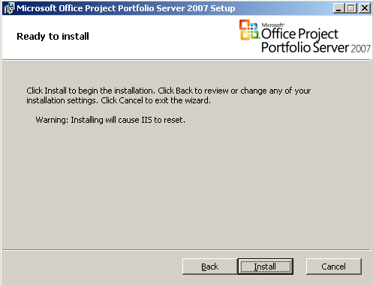
Figure 21. Microsoft Office Project Portfolio Server 2007 Setup — Ready to install
- When the Installer finishes, click Finish to complete the installation process.

Installing the Office Project Portfolio Server 2007 Reporting Tier
This section elaborates on installing the reporting tier of Office Project Portfolio Server 2007 if SQL Server Reporting Services is installed on a different computer from Office Project Portfolio Server 2007 (see scenarios 1–3).
Important:
This section is not relevant if you installed Office Project Portfolio Server 2007 on the same computer as SQL Server Reporting Services, and if you installed the Reporting Services Configuration component during installation of Office Project Portfolio Server 2007 (see page 40).
To install the Office Project Portfolio 2007 reporting server:
- From the Office Project Portfolio Server 2007 installation CD, start the PPS.MSI Installer.
- Review the license terms. If you accept the terms, select the corresponding box and click Next.
Figure 22. Microsoft Office Project Portfolio Server 2007 Setup — Microsoft Software License Terms
- Enter the 25-character Product Key that came with the Office Project Portfolio Server 2007 installation CD, and click Next.
Figure 23. Microsoft Office Project Portfolio Server 2007 Setup — Enter your Product key
- Select the Site under which you want to install Office Project Portfolio Server 2007. The location you choose is irrelevant, because in the next step you will not install the main component but only the Reporting Services components.
Figure 24. Microsoft Office Project Portfolio Server 2007 Setup — Select Installation Address
- Select the features you want to install, and click Next.
- Web Site does not need to be installed on the reporting server if SQL Server Reporting Services is installed on a different computer from Office Project Portfolio Server 2007 (see scenarios 1–3).
- Scheduler Service does not need to be installed on the reporting server if SQL Server Reporting Services is installed on a different computer from Office Project Portfolio Server 2007 (see scenarios 1–3).
- Reporting Services configuration contains the standard reports and configuration changes necessary for Office Project Portfolio Server 2007 to run reports. Set the feature to install, and then browse to the Reporting Services installation location, typically located under C:\Program Files\Microsoft SQL Server\MSSQL.instance\Reporting Services\ReportServer.
- Portfolio Component contains necessary binaries of Office Project Portfolio Server 2007 to be installed on the reporting server. Set the feature to install, and then browse to a directory where you want to install this subcomponent.
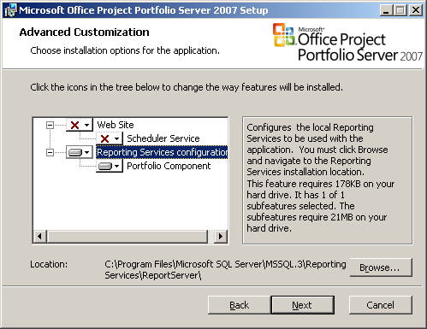
Figure 25. Microsoft Office Project Portfolio Server 2007 Setup — Advanced Customization
Important:
Set the Reporting Services configuration feature to install and then browse to the Reporting Services installation location, typically located under C:\Program Files\Microsoft SQL Server\MSSQL.instance\Reporting Services\ReportServer. Failing to provide the correct path will result in a failure of the installation of the reporting tier.
- Specify the Primary Database server on which Office Project Portfolio Server 2007 databases were installed in the previous section. Click Next.
Figure 26. Microsoft Office Project Portfolio Server 2007 Setup — Setup Installation Parameters, Database connection information
- Specify the Reporting Services URL. Because you are installing on the reporting server computer, this typically is http://localhost/ReportServer/.
- Specify the Reports Folder in which all Office Project Portfolio Server 2007 reports will be saved (default “/Reports”).
- The SMTP Server and From Address can be left blank when installing only the Office Project Portfolio Server 2007 reporting tier.
Figure 27. Microsoft Office Project Portfolio Server 2007 Setup — Setup Installation Parameters, Reporting Services parameters and SMTP information
- Click Install to start the installation of the Office Project Portfolio Server 2007 reporting tier.
- The Installer will restart your Web server component.
Figure 28. Microsoft Office Project Portfolio Server 2007 Setup — Ready to install
Note: The Portfolio Component installed includes a file named Web.config. This file contains the installation and connection parameters. In case of network configuration changes, this file needs to be updated on both the reporting server and the application server.
For more information connection parameters, see the Configuring the Installation Parameters section in the Appendix of this document. For more information about security permissions required in a distributed environment for the reporting server, see the Account and Permission Requirements for Server Farm Deployment Scenarios section in the Appendix of this document.

Office Project Server 2007 Connection (Gateway)
The Project Server Gateway in Office Project Portfolio Server 2007 enables synchronization of the following data between multiple Office Project Server 2007 instances:
- Projects
- Enterprise project custom fields
- Enterprise resources
- Enterprise resource assignments
- High-level tasks
- Milestones
The Project Server Gateway enables detail-level project management in Office Project Server 2007 while rolling up data to Office Project Portfolio Server 2007.
This section describes how to set up and test a basic connection between the Office Project Portfolio Server 2007 and Office Project Server 2007 and describes some of the functionality of the Project Server Gateway.

Office Project Server 2007 Configuration Requirements
Prior to setting up the Project Server Gateway in the Office Project Portfolio Server 2007 Web interface, some security configuration steps might need to be completed in the SharePoint Central Administration Web site to enable communication between Office Project Portfolio Server 2007 and Office Project Server 2007. The configuration requirements depend on the following Office Project Portfolio Server 2007 and Office Project Server 2007 deployment scenarios.

Scenario 1: Office Project Server 2007 and Office Project Portfolio Server 2007 are installed on separate servers that do not trust each other
Only Project Server forms authentication can be used in this scenario. No additional security configuration is required within Central Administration.

Scenario 2: Office Project Server 2007 and Office Project Portfolio Server 2007 are installed on the same server and only one Shared Services Provider has been defined in Central Administration
No additional security configuration is required within Central Administration.

Scenario 3: Office Project Server 2007 and Office Project Portfolio Server 2007 are installed on the same server and multiple Shared Services Providers have been defined in Central Administration
Here we assume the application pool identity for Office Project Portfolio Server 2007 is the default NT Authority\Network Service account.
- Log on to Central Administration on the server.
- Click the Application Management tab.
- Select the This farm will provide services to other farms option.
- Add user NT Authority\Network Service to the Users list in the Provide Shared Services section.
- Click OK.

Scenario 4: Office Project Server 2007 and Office Project Portfolio Server 2007 are installed on separate servers and the Office Project Portfolio Server 2007 application pool identity is configured to use the NT Authority\Network Service account
Follow the same steps defined for scenario 3, except add the domain\machinename$ account to the Users list in step 4 instead of the NT Authority\Network Service account.

Scenario 5: Office Project Server 2007 and Office Project Portfolio Server 2007 are installed on separate servers and the Office Project Portfolio Server 2007 application pool identity is configured to use a domain account
The Windows user account configured for the application pool identity on the computer running Office Project Portfolio Server 2007 must be given permission to the Shared Services Provider hosting Office Project Server 2007.
- Log on to Central Administration on the server.
- Click the Shared Services Administration link on the left navigation pane.
- Edit the properties of the Shared Services Provider for Office Project Server 2007.
- Add user domain\user name to the Users list in the Process Account with access to this SSP section. The account should match the account configured for the application pool identity on the computer running Office Project Portfolio Server 2007.
- Click OK.

Project Server Gateway Setup
Because Internet Explorer is restricted by default on Windows Server 2003 platforms, it is recommended for further configuration to use a different client computer to link Office Project Server 2007 with Office Project Portfolio Server 2007.
- Open Internet Explorer on your client computer and enter the following URL:
http://servername/PortfolioServer
where servername is replaced by the IP address, NetBIOS name, or fully qualified domain name (FQDN) of the computer running Office Project Portfolio Server 2007.
- Log on by using an administrator account. For information about how to set up this account, see the Creating an Administrator User section of this document.
- To access the Project Gateway Settings section, go to Settings > Project Server Gateway. Here, the user can configure all the necessary settings to properly link Office Project Server 2007 with Office Project Portfolio Server 2007.
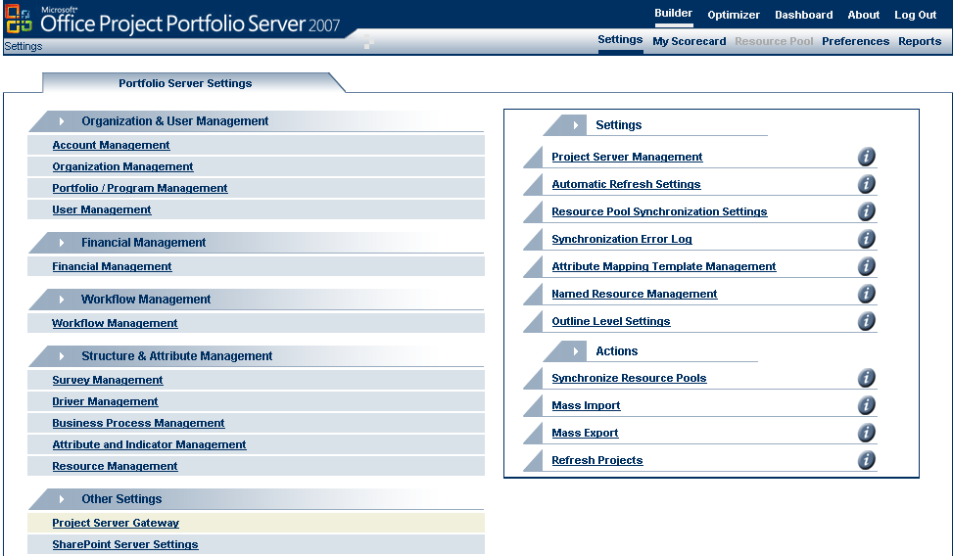
Figure 29. Project Server Gateway — Portfolio Server Settings
- Click Project Server Management, and then click Add to define a new connection with an instance of Office Project Server 2007.
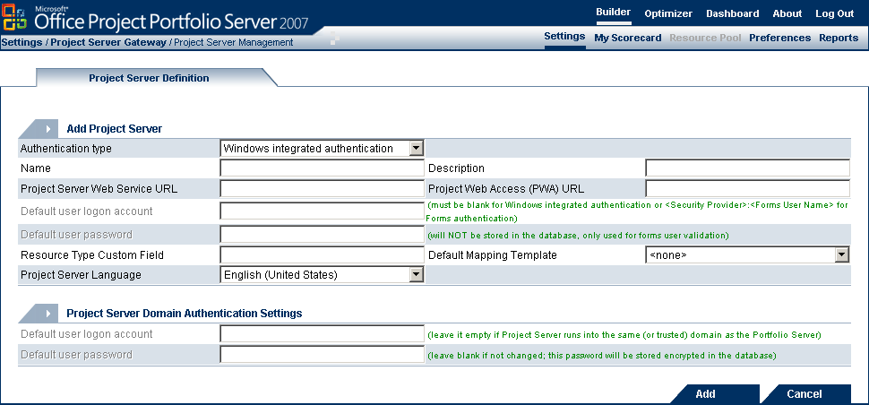
Figure 30. Project Server Gateway — Project Server Definition
- The following are the minimal settings to do a first connection test between Office Project Server 2007 and Office Project Portfolio Server 2007.
- Authentication type: Depending on the authentication method configured for Office Project Portfolio Server 2007 in the Web.config file, choose between:
- Integrated Windows authentication (default): This option will only work if the Office Project Portfolio Server 2007 Web.config file is set up to use Integrated Windows authentication.
Note: Before individual Windows authenticated users can use the Project Server Gateway, they must first click the Preferences link in the Office Project Portfolio Server 2007 Web interface. This will initialize the user’s connection to Office Project Server 2007.
- Forms authentication
- Name: Choose a name of the Office Project Server 2007 instance.
- Description: Choose a description of the Office Project Server 2007 instance.
- Project Server Web Service URL: URL to reach the Shared Services Provider for Office Project Server 2007 — for example, http://[ProjectServerApplicationServer]:56737/SharedServices1.
- Project Web Access (PWA) URL: URL to reach the Web access component of Office Project Server 2007 — for example, http://[ProjectServerWebAccessServer]/PWA.
- Default user login account: User name to access the account (must be blank for Integrated Windows authentication or <Security Provider>:<Forms User Name> for forms authentication).
- Default user password: Password to access the account (used only for forms authentication).
- Resource Type Custom Field: Enterprise Resource Outline Code, used to define the mapping of a named resource in Office Project Server 2007 to its resource type as it is defined in Office Project Portfolio Server 2007 (assuming this field is the same as Enterprise Resource Outline Code).
- Default Mapping Template: Select a default mapping template to be used in all imports and exports with the defined Project Server.
- Project Server Domain Authentication Settings: Select the user login account and user password if Office Project Server 2007 and Office Project Portfolio Server 2007 are installed on separate servers that do not trust each other. Click Add to add the Project Server definition.
- Go to Settings > Project Server Gateway > Attribute Mapping Template Management. Click Add. Here, the user can configure the mapping between enterprise fields in Office Project Server 2007 and attributes in Office Project Portfolio Server 2007. Project Server custom fields will be mapped to attributes as shown in the following table.
Table 4. Custom Field to Attribute Mapping
Project Server enterprise custom field type | Portfolio Service attribute type
Text with Lookup Table | List
Cost, Cost with Lookup Table  Number, Number with Lookup Table | Number
Date, Date with Lookup Table | Date
Text | String
Text with Multi-value Lookup Table | Multiple Text

Note: Types excluded from the preceding table are not supported, for example Flag and Duration.
- In the Server Name drop-down box on the right, select the Office Project Server 2007 instance you previously created.
If the screen changes with a list of Project Attributes and multiple drop-down boxes, the gateway connection is working. After defining an attribute mapping template, you should specify the mapping template as the default for your Project Server definition.
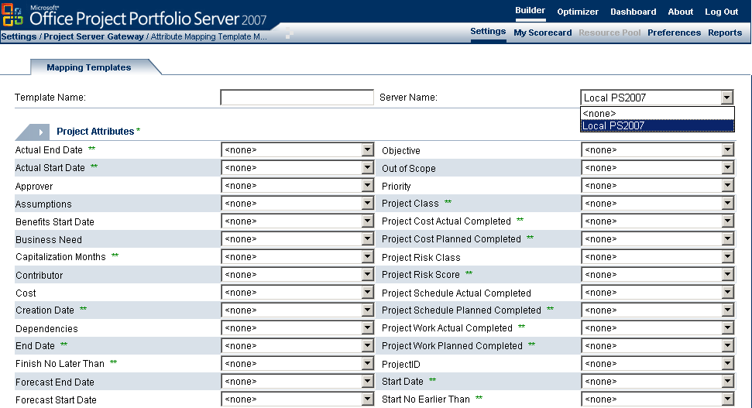
Figure 31. Project Server Gateway — Mapping Templates

Windows SharePoint Services 3.0 Connection
This section includes the steps to be followed to configure the link between Office Project Portfolio Server 2007 and Windows SharePoint Services 3.0 to be used as the document management engine.
As an initial step, define the SharePoint server definition in Office Project Portfolio Server 2007. Next, define which user is used to connect to Windows SharePoint Services 3.0. Finally, link the SharePoint server to an organization in Office Project Portfolio Server 2007.
Create the SharePoint server definition:
As a first initial step, define the SharePoint server definition, consisting of the URL to access Windows SharePoint Services 3.0.
- Open Internet Explorer on your client computer and enter the following URL:
http://servername /PortfolioServer
where servername is replaced by the IP address, NetBIOS name, or FQDN of the computer running Office Project Portfolio Server 2007.
- Log on by using an administrator account. For information about how to set up this account, see the Creating an Administrator User section of this document.
- To access the SharePoint Server Settings section, go to Settings > SharePoint Server Settings. Here, the user can configure all the necessary settings to properly link Windows SharePoint Services 3.0 with Office Project Portfolio Server 2007 for document management.
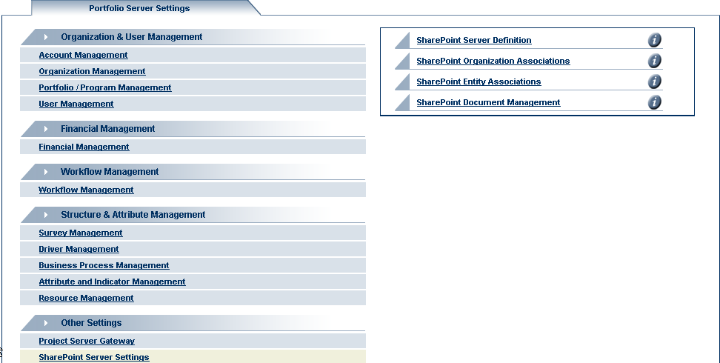
Figure 32. Portfolio Server Settings
- Click the SharePoint Server Definition link.
- Click the Add button, and fill in the following information:
- Name — Enter a name for the new Windows SharePoint Services 3.0.
- Description — Enter a descriptive text about the SharePoint server.
- URL — Enter the URL for Windows SharePoint Services 3.0.
- Click Add.
Note: It is strongly recommended that you use SSL to connect to Windows SharePoint Services 3.0 by using a URL that starts with https. This prevents transmission of clear text user name/password information over the network.
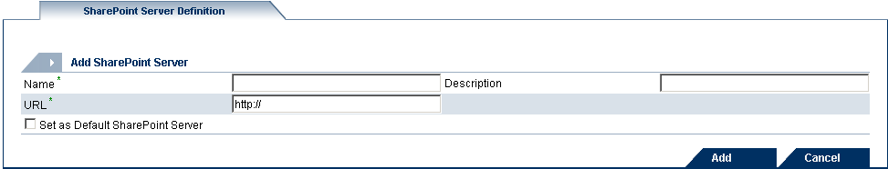
Figure 33. SharePoint Server Definition
Define the SharePoint User Settings:
Office Project Portfolio Server 2007 impersonates you when it connects to Windows SharePoint Services 3.0. Therefore, for each user defined in Office Project Portfolio Server 2007, you need to specify a Windows domain user used to access Windows SharePoint Services 3.0.
- Go to the Preferences screen by clicking the link on the top menu, and then select SharePoint Servers.
- Select the SharePoint server you added in the previous section, and click Edit.
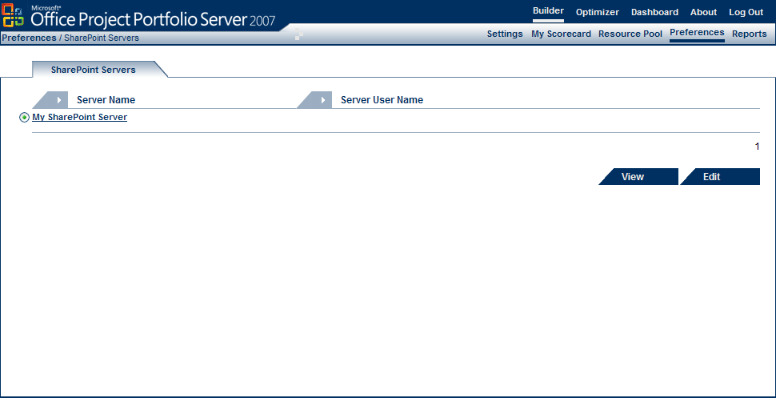
Figure 34. SharePoint Servers
- Type the user credentials used to connect to Windows SharePoint Services 3.0, consisting of the domain, user name, and password (enter it twice).
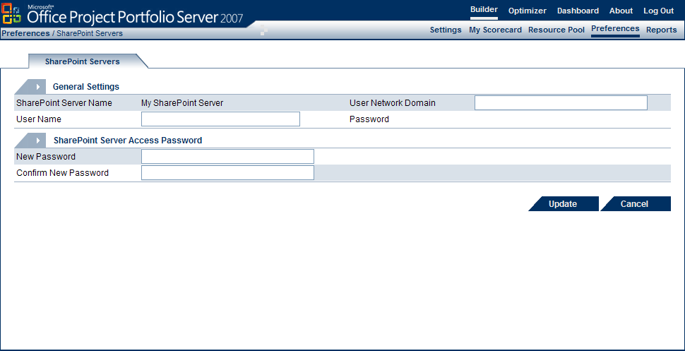
Figure 35. SharePoint Servers — General Settings
Associate the SharePoint server to an organization in Office Project Portfolio Server 2007:
- On the Settings screen, click the SharePoint Organization Associations link.
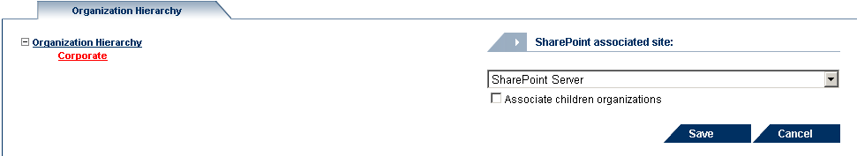
- Associate the Windows SharePoint Services 3.0 defined in the previous step to each organization (select the Associate children organizations check box to associate all the children organizations).
Figure 36. SharePoint Organization Associations — Organizational Hierarchy
- Click Save to return to the Settings screen.
Associate SharePoint sites to Office Project Portfolio Server 2007 projects, applications, or programs:
- On the Settings screen, select SharePoint Entity Associations.
- On the SharePoint Entity Association screen, associate the Windows SharePoint server defined in the previous step to each entity (for instance, projects, programs, or applications).
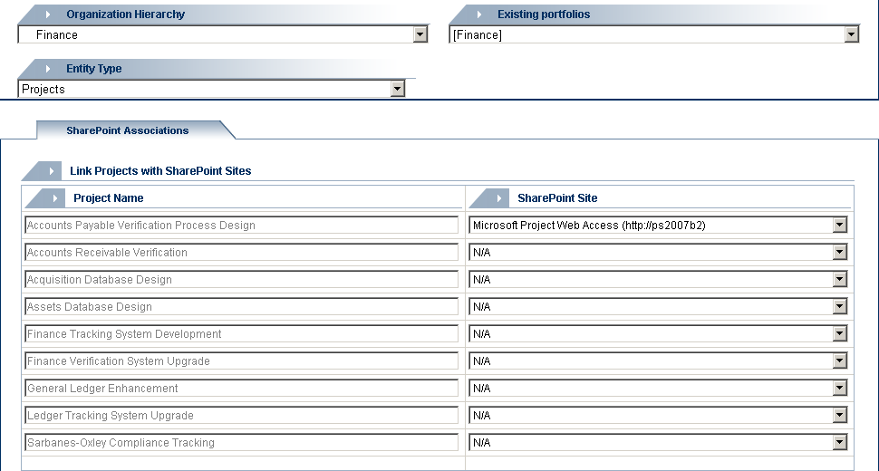
Figure 37. SharePoint Entity Associations
Note: On the Settings screen, select Windows SharePoint Document Management to centrally manage the SharePoint document management system main Web site.
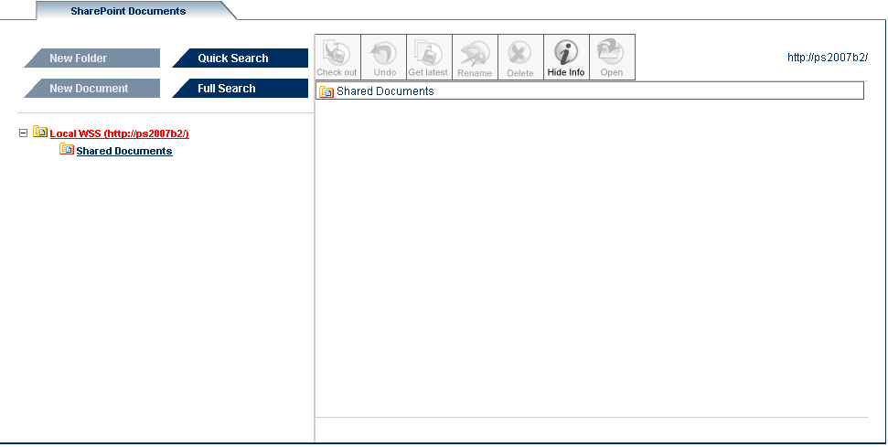
Figure 38. SharePoint Organization Associations — SharePoint Documents

System Configuration Tests
This section describes how to test the previous installation of Office Project Portfolio Server 2007 and all of the subcomponents.
- The first step is to verify that the required services are running.
- The second step is to create an “Administrator” type of user.
Further tests include testing the gateway to Office Project Server 2007, along with the connections to SQL Server Reporting Services and Windows SharePoint Services 3.0.
In this section:
- Testing Office Project Portfolio Server 2007 Services
- Testing SQL Server Reporting Services Connection
- Office Project Server 2007 Connection (Gateway)

Testing Office Project Portfolio Server 2007 Services
To verify that the Office Project Portfolio Server 2007 application is running, ensure that the following services are running:
- World Wide Web Publishing Service
- Office Project Portfolio Server Scheduler
- In Control Panel, double-click Administrative Tools.
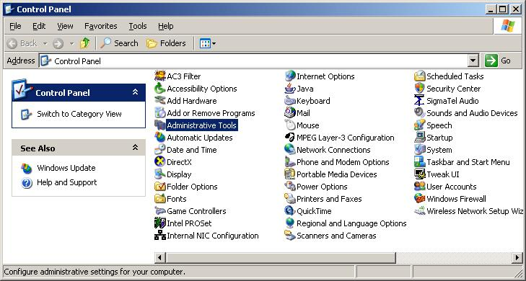
Figure 39. Control Panel — Administrative Tools
- Double-click Services. Verify that the services mentioned previously are running.
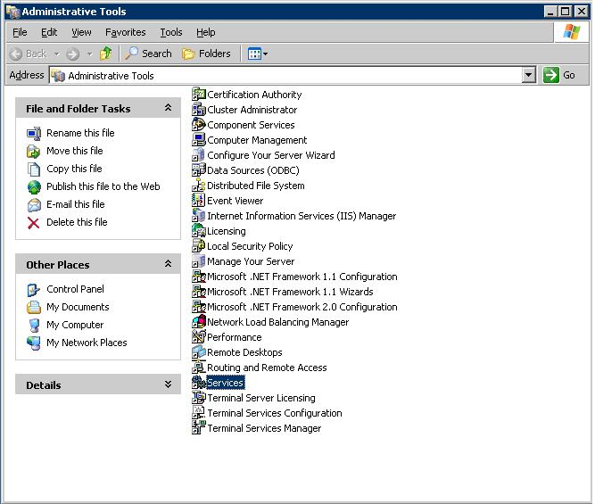
Figure 40. Control Panel — Administrative Tools, Services

Logging on to Office Project Portfolio Server 2007
This section lists the steps needed to log on to the system to test whether Office Project Portfolio Server 2007 was successfully installed.
To log on to Office Project Portfolio Server 2007:
- Open Internet Explorer on the computer running Office Project Portfolio Server 2007, and enter the following URL:
http://servername/PortfolioServer
where servername is replaced by the IP address, NetBIOS name, or FQDN of the computer running Office Project Portfolio Server 2007.
- Log on by using an administrator account. For information about how to set up this account, see the Creating an Administrator User section of this document.
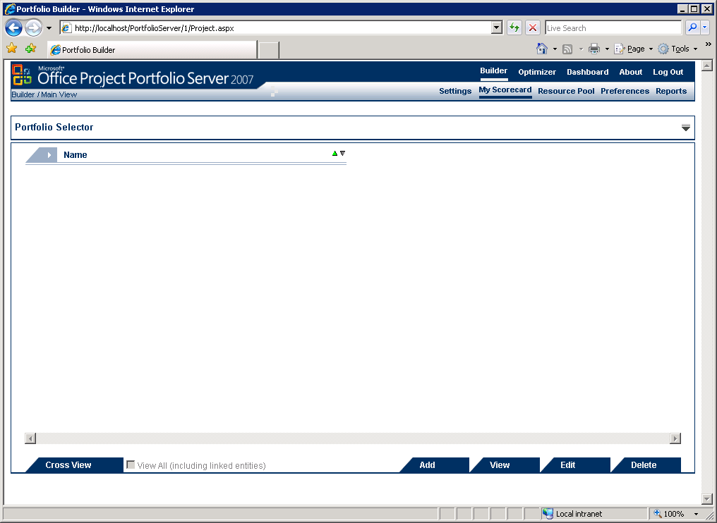
Figure 41. Microsoft Office Project Portfolio Server 2007 — Portfolio Builder
This screen appears. By default, you are a Super user. This means that you are able to add accounts and users, but you cannot configure the application. The Super user account is the same Windows user account used to install Office Project Portfolio Server 2007.
The next section discusses how to add an Administrator user that can configure the software.
Note: If you specified a different site or virtual directory during installation, the URL mentioned previously should be updated accordingly. For information about how to set up site and virtual directory names and locations, see the Installing Office Project Portfolio Server 2007 section of this document.

Creating an Administrator User
The default installation includes only one user, the Super user. This is the same Windows user account used to install Office Project Portfolio Server 2007.
As a Super user, you can only add accounts and users, but you cannot configure Office Project Portfolio Server 2007.
To configure the system, create an Administrator user. In other words, log on to the application as a Super user, create an Administrator user, log out, and then log on again as an Administrator to configure the application.
To create an Administrator user:
- On the Settings screen, select User Management, and then User Group Management.
- Click the Add User Group tab. Name the group Administrator and select Allow for all the rights, and then click Add.
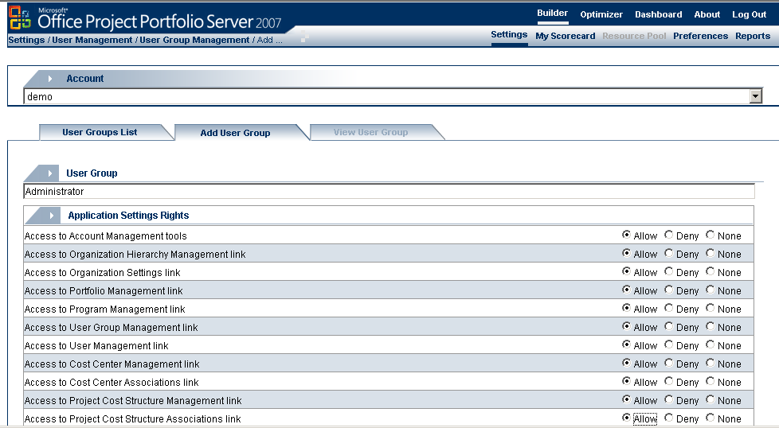
Figure 42. User Group Management — Add User Group
- Return to the Settings screen, select User Management, and then select User Management.
- Click the Add User tab. Choose Admin as the login name, and use Administrator for the full name.
- Choose and confirm a password.
- Select Administrator for organization rights assignment, and click Add.
By default, the following password policy is configured:
- Minimum six characters long.
- Minimum one numeral and minimum one uppercase character.
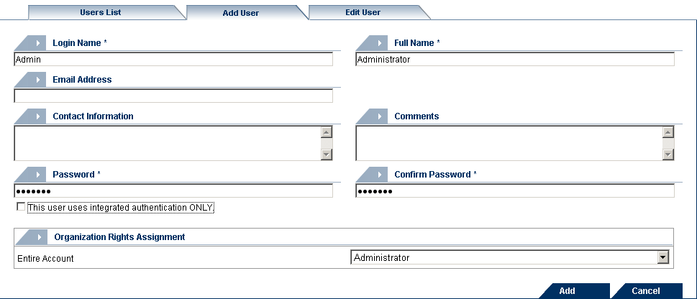
Figure 43. User Management — Add User
Important:
Before continuing with further configuration, it is recommended that you configure the Start of the fiscal year setting in the account settings page. This setting can no longer be changed after building the organizational structure.
Note: The use of a different client computer is recommended for further configuration, because Internet Explorer is restricted by default on Windows Server 2003 platforms (Internet Explorer Enhanced Security).

Testing SQL Server Reporting Services Connection
To verify that the SQL Services Reporting Services installation and configuration was successful, the following two tests can be performed:
- Check the uploaded reports.
- Generate a report.

Checking the Uploaded Reports
- Browse to your SQL Server Reporting Services report server URL, as specified during the installation. Typically, this is on the reporting server http://localhost/ReportServer.
- The Office Project Portfolio Server 2007 installation wizard created a directory named Reports, or the name you specified during the installation.
- Click this directory to get a list of 25 reports and one data source named PPSAccountIndex.
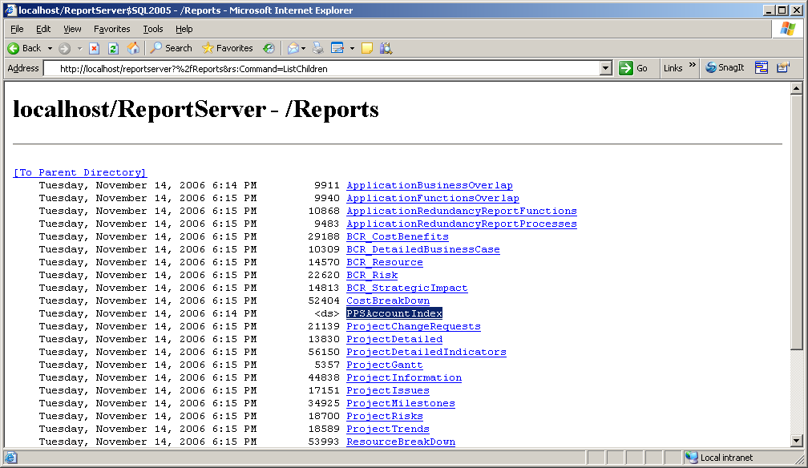
Figure 44. Localhost/ReportServer — /Reports

Generating a Report
As a second test, generate a Microsoft Office Excel® report through Office Project Portfolio Server 2007. The use of a different client computer is recommended for further configuration, because Internet Explorer is restricted by default on Windows Server 2003 platforms by Internet Explorer Enhanced Security.
- Open Internet Explorer on your client computer and browse to the following URL:
http://servername/PortfolioServer
where servername is replaced by the IP address, NetBIOS name, or FQDN of the computer running Office Project Portfolio Server 2007.
Log on by using an administrator account. For information about how to set up this account, see the Creating an Administrator User section of this document.
- Click the Settings link, followed by User Security and Session Tracking.
- Click the Failed Login Attempts link.
- Click the Generate Report button.
If a window opens asking you to save the generated Office Excel file, the reporting server connection was successfully installed.

Office Project Portfolio Server 2007 Client Installation
In this section:
- System Requirements for Project Portfolio Web Access
- Client Computer Settings

System Requirements for Project Portfolio Web Access
Project Portfolio Web Access is a Web portal used to access the information stored in Office Project Server 2007. Using Project Portfolio Web Access requires an Office Project Portfolio Server 2007 Client Access License (CAL).
The following table summarizes the minimum requirements for using Project Portfolio Web Access.
Table 5. System Requirements for Project Portfolio Web Access
Component | Requirement
Computer and processor | 700 megahertz (MHz) processor or higher
Memory | 128 MB of RAM or more recommended (additional memory might be required depending on operating system requirements)
Hard disk | 40 MB of available hard disk space per workstation
Operating system | Windows XP SP2 or later, Windows XP Tablet Edition SP1 or later, Windows Vista™ required
Display | Minimum 800 × 600; 1024 × 768 or higher-resolution monitor recommended
Browser | Internet Explorer 6.0 with service packs or Internet Explorer 7, 32-bit browser version
Network connection | 256 KB or higher connection
Other | Office Excel 2003 or Office Excel 2007 is required to load the matrix views in the Portfolio Optimizer module and generate reports.  Adobe Acrobat 6.0 (or higher) is required to generate PDF reports.
Office Project Portfolio Server 2007 requires that browser settings are set at their default values. If the client computer is able to download and install ActiveX® controls (for example, for users who are local administrators or power users), the following settings for Internet Explorer and Office Excel should be verified to run the Optimizer.

Client Computer Settings
For the Office Project Portfolio Server 2007 application to run properly, the following settings for Internet Explorer and Office Excel should be verified.

Configuration for ActiveX
The client computer must be able to download and install ActiveX files. Follow the following steps to ensure that the client computer is configured properly.

Internet Explorer 6.0
If your Internet browser is Internet Explorer 6.0:
- Go to the main menu at the top of the screen, and click Tools.
- Select Internet Options. A dialog box will appear.
- Click the Security tab.
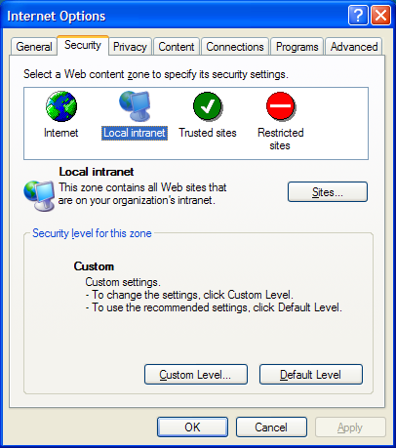
Figure 45. Internet Explorer 6.0 — Internet Options, Security tab
- If the application is hosted on the Internet, select Trusted sites and add the application URL to your trusted sites.
OR
- If the application is hosted on the company intranet, select the Local intranet zone.
- Click Custom Level in either the Local intranet or the Trusted sites section.
- The Security Settings window will appear.
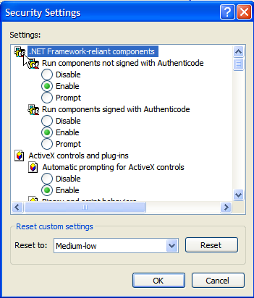
Figure 46. Internet Explorer 6.0 — Security Settings
- Set the following settings:
- Under the ActiveX controls and plug-ins header:
- Download signed ActiveX controls: Prompt or Enable
- Run ActiveX controls and plug-ins: Prompt or Enable
- Script ActiveX controls marked safe for scripting: Prompt or Enable
- Under the Miscellaneous header:
- Submit nonencrypted form data: Prompt or Enable
- Scripting: Prompt or Enable
- Active scripting: Prompt or Enable
- Click OK to apply your selections.
- Click the Privacy tab.
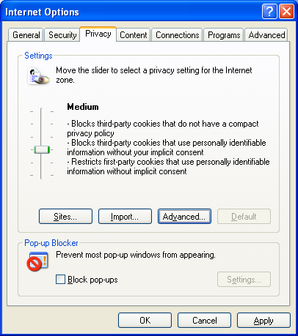
Figure 47. Internet Explorer 6.0 — Internet Options, Privacy tab
- Ensure that the Block pop-ups check box is cleared (check box at the bottom of the window).

Internet Explorer 7
If your Internet browser is Internet Explorer 7:
- Go to the main menu at the top of the screen, and then click Tools.
- Select Internet Options. A dialog box will appear.
- Click the Security tab.
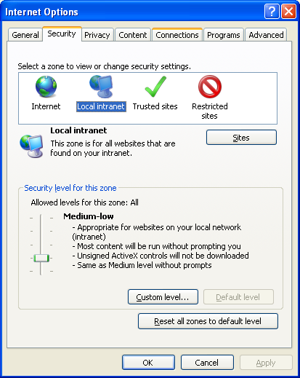
Figure 48. Internet Explorer 7 — Internet Options, Security tab
- If the application is hosted on the Internet, select Trusted sites and add the application URL to your trusted sites, and then click Add.
OR
- Select the Local intranet zone if the application is hosted on the company intranet.
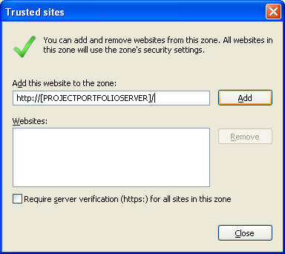
Figure 49. Internet Explorer 7 — Trusted sites
- Click Custom Level in either the Local intranet or Trusted sites section.
- The Security Settings – Trusted Sites Zone window will appear.
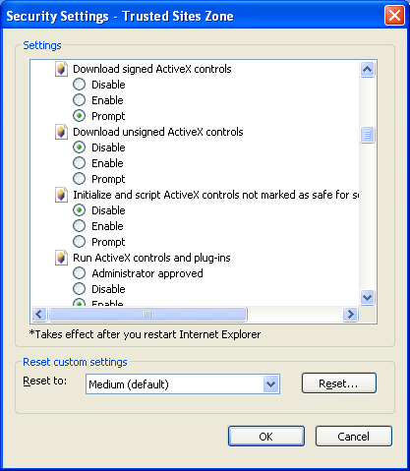
Figure 50. Internet Explorer 7 — Security Settings - Trusted Sites Zone
- Set the following settings:
- Under the ActiveX controls and plug-ins header:
- Download signed ActiveX controls: Prompt or Enable
- Run ActiveX controls and plug-ins: Prompt or Enable
- Script ActiveX controls marked safe for scripting: Prompt or Enable
- Under the Miscellaneous header:
- Submit nonencrypted form data: Prompt or Enable
- Scripting: Enable or Prompt
- Active scripting: Prompt or Enable
- Click OK to apply your selections.
- Click the Privacy tab, and ensure that the Turn on Pop-up Blocker check box is cleared.
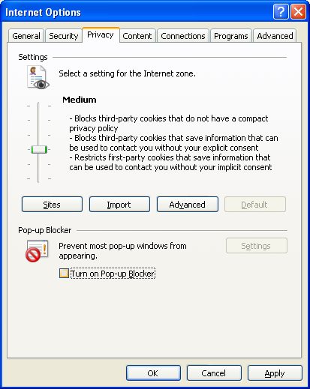
Figure 51. Internet Explorer 7 — Internet Options, Privacy tab

Configuration for Microsoft Visual Basic Access
Office Project Portfolio Server Optimizer and the Import wizard use certain Microsoft Visual Basic® components of Office Excel. For Office Project Portfolio Server 2007 to be able to access Office Excel 2003, the following settings need to be completed.
Office Excel 2003
- Go to the Tools menu, select Macro, and click the Security option.
- The Security dialog box will appear. Select the Trusted Publishers tab.
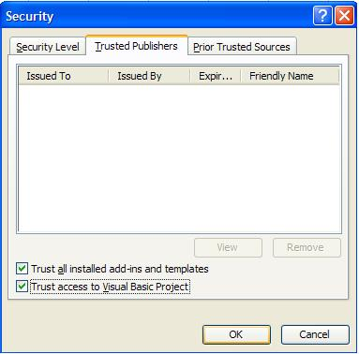
Figure 52. Office Excel — Security, Trusted Publishers
- Ensure that the Trust access to Visual Basic Project check box is selected.

Office Excel 2007
- In Office Excel 2007, click the Office icon on the upper-left corner.
- Select Excel Options.
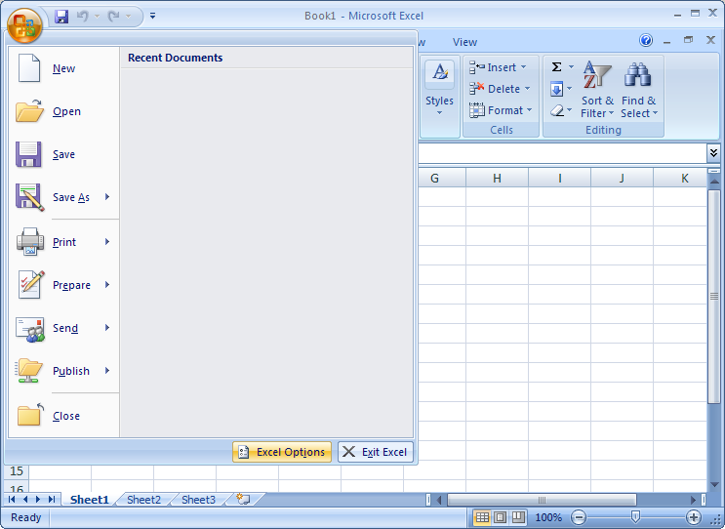
Figure 53. Office Excel 2007 — Excel Options
- The Excel Options box will appear.
- Select the Trust Center link, and click the Trust Center Settings button.
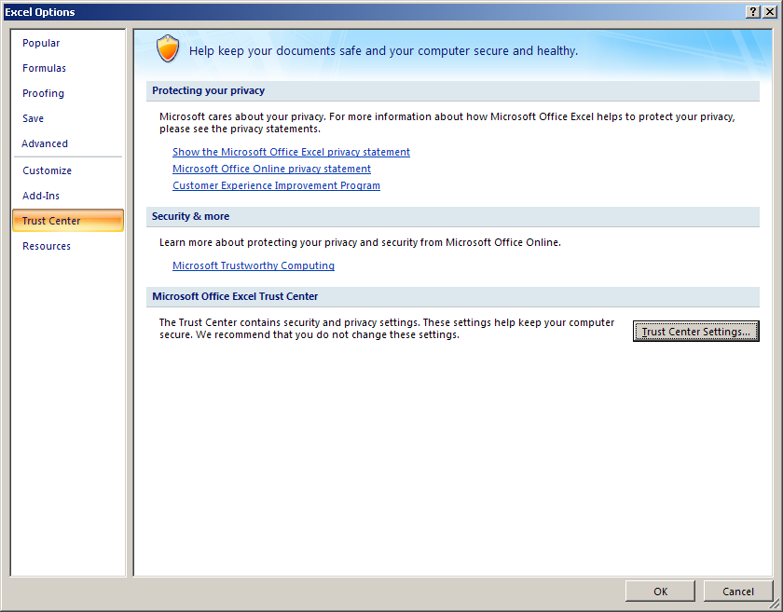
Figure 54. Office Excel 2007 — Excel Options, Trust Center
- Select the Macro Settings link.
- Check the Trust access to the VBA project object model check box.
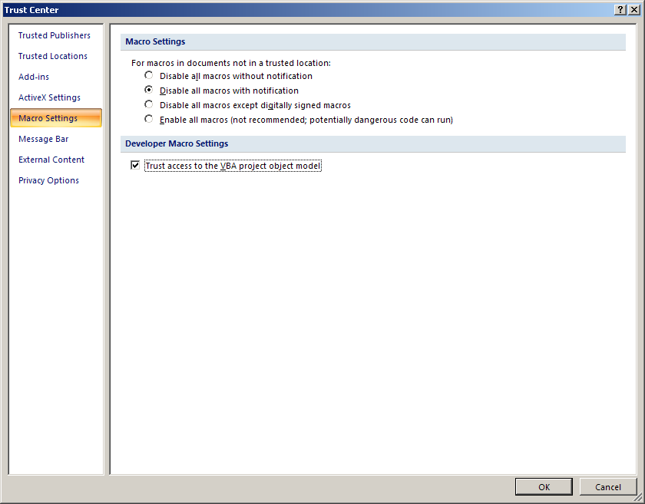
Figure 55. Office Excel 2007 — Excel Options, Trust Center, Macro Settings
- Click OK to close the Trust Center screen.
- Click OK again to close the Excel Options window.
- Close Office Excel 2007.
- Restart Internet Explorer to apply the changes.

Configuration for Windows Vista
Internet Explorer 7 in Windows Vista runs by default in Protected Mode. Protected Mode greatly restricts Internet Explorer 7 privileges. Protected Mode prevents some of the functions of Office Project Portfolio Server 2007 from running properly.
To run Office Project Portfolio Server 2007 in Internet Explorer 7 in Windows Vista, disable the Protected Mode in addition to the other Internet Explorer 7 settings.
- In the Internet Explorer 7 main menu, go to Tools.
- Select Internet Options, and then click the Security tab.
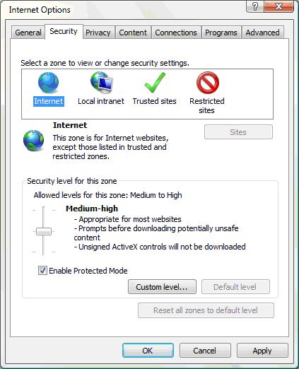
Figure 56. Internet Explorer 7 in Windows Vista — Internet Options, Security tab
- Clear the Enable Protected Mode check box.
- Click OK, and then restart Internet Explorer to apply the changes.

Troubleshooting
This section explores how to troubleshoot the most common issues during the installation of Office Project Portfolio Server 2007.
In this section:
- Server Error when starting Office Project Portfolio Server 2007
- 404 File Not Found Error when starting Office Project Portfolio Server
- Case-sensitive SQL Server
- E-mail link does not work
- Blocker Programmatic
- Mass Export to Office Project Server 2007 fails

Server Error when starting Office Project Portfolio Server 2007
Symptom:
When browsing to the login URL of Office Project Portfolio Server 2007, the following error message is shown:
Configuration Error
Could not load file or assembly ‘Microsoft.Office.Project.PortfolioServer.Optimizer …
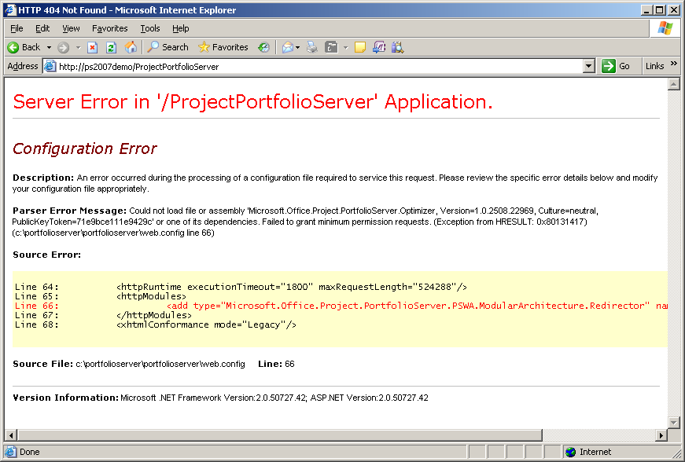
Figure 57. Configuration Error
Solution:
This error might appear if you install Office Project Portfolio Server 2007 on the same Web site as Windows SharePoint Services 3.0. Uninstall Office Project Portfolio Server 2007, create a new Web site, and reinstall Office Project Portfolio Server 2007 under the new Web site. For more information, see page 30.

404 File Not Found Error when starting Office Project Portfolio Server 2007
Symptom:
When browsing to the login URL of Office Project Portfolio Server 2007, an error message 404 File Not Found is shown.
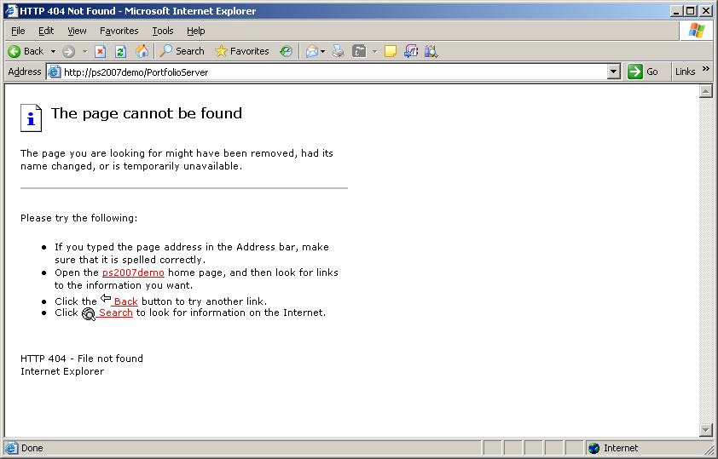
Figure 58. HTTP 404 Not Found
Solution:
When installing Office Project Portfolio Server 2007, the user should specify the installation location to the correct path corresponding to the virtual Web site.
Select the features you want to install, and click Next. See step 8 on page 40.

Case-sensitive SQL Server
Symptom:
During setup, the following error appears:
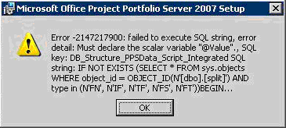
Figure 59. Setup Error
Solution:
Office Project Portfolio Server 2007 does not support case-sensitive deployments of SQL Server 2005.

E-mail link does not work
Symptom:
Office Project Portfolio Server 2007 sends out e-mail but the link mentioned in the e-mail is not working.
Solution:
The e-mail link will be a default link containing the server’s name. If the application server is configured to accept requests under a different host header — for instance, the FQDN — change the Web.config file. For more information, see the Configuring the Installation Parameters section in the Appendix on page 92.

Pop-up Blocker
Symptom:
Internet Explorer reports an error: "An outgoing call cannot be made because the application is dispatching an input-synchronous call" when saving a matrix in the Portfolio Optimizer.
Solution:
Ensure that your pop-up blocker allows pop-ups for the Office Project Portfolio Server 2007.

Programmatic Access to Visual Basic Project Error
Symptom:
When running the Portfolio Optimizer, the following error appears:
Programmatic Access to Visual Basic Project is not Trusted.
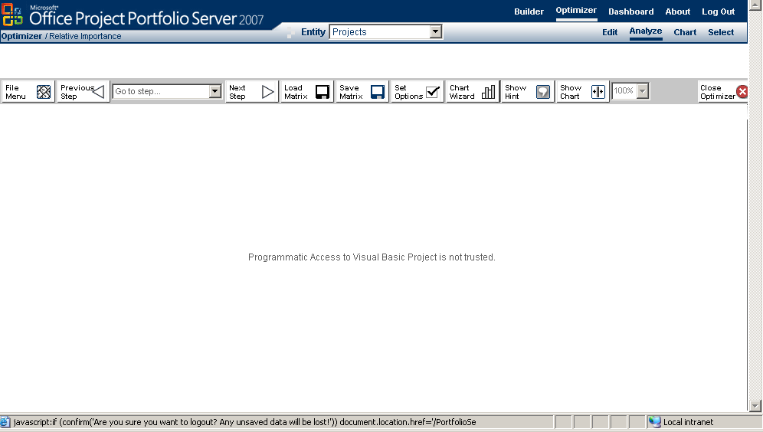
Figure 60. Optimizer — Visual Basic Error
Solution:
Ensure that Office Excel software on the client computer is configured properly. If the Office Excel setting cannot be changed, it might be because the user does not have administrative rights to change the setting on the workstation; contact the desktop administrator.
Note: Sometimes there is a delay between changing the Office Excel setting and having it overwritten by a refresh from a centralized LAN management utility.

Mass Export to Office Project Server 2007 fails
Symptom:
When executing a mass export from Office Project Portfolio Server 2007 to Office Project Server 2007, the following error message appears:
Warning: "Export operation for project 'XXXX' encountered an error: Could not create project. A required custom field value was not provided.
Solution:
Exporting a project to Office Project Server 2007 fails if, in Office Project Server 2007, there are:
- Required custom fields of type duration for Projects
- Required custom fields of any type for Tasks
There is no way to map these types of fields. To be able to export projects from Office Project Portfolio Server 2007, those fields should be made nonmandatory.

Appendix

Configuring the Installation Parameters
The Office Project Portfolio Server 2007 installation wizard configures the connection parameters to the database server, reporting server, and SMTP server during installation. This section explains how to manually adjust these parameters if one of the connected systems has changed after installation. All settings during installation are specified in the Web.config file located on the Office Project Portfolio Server 2007 application server.
Note: If the reporting tier is installed on a separate computer (see scenarios 1–3), a corresponding Web.config file will be installed on the reporting server. Adjustments should be made in both files.
- Open the ProjectPortfolio2007 folder of the application server or the reporting server (for example, C:\Inetpub\wwwroot\ProjectPortfolio2007).
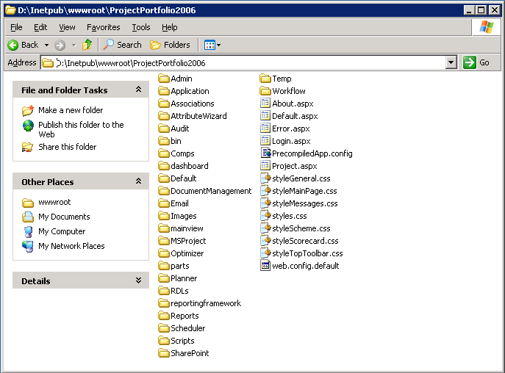
Figure 61. C:\Inetpub\wwwroot\ProjectPortfolio2007
- Open the Web.config files. Scroll to the middle of the screen, to the “<appSettings>” section.
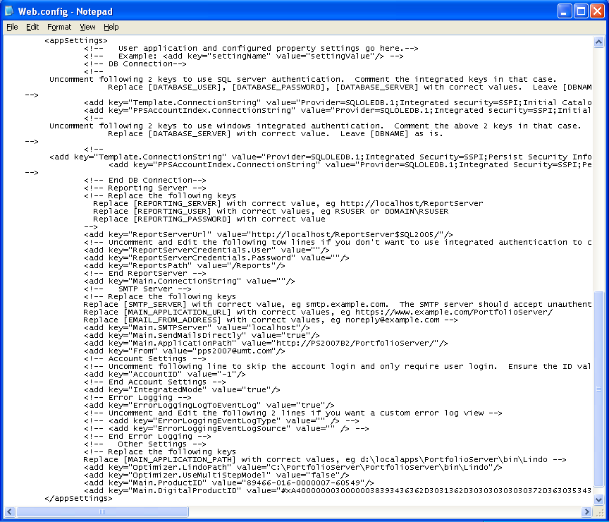
Figure 62. Web.config file — <appSettings>

Database Server connection
The database server connection is specified in the following lines:
<add key="Template.ConnectionString" value="Provider=SQLOLEDB.1;Integrated security=SSPI;Initial Catalog=[DBNAME];Data Source=[DATABASESERVER];Workstation ID=PS2007B2;Use Procedure for Prepare=1;Auto Translate=True;Packet Size=4096"/>

<add key="PPSAccountIndex.ConnectionString" value="Provider=SQLOLEDB.1;Integrated security=SSPI;Initial Catalog=PPSAccountIndex;Data Source=[DATABASESERVER];Workstation ID=PS2007B2;Use Procedure for Prepare=1;Auto Translate=True;Packet Size=4096"/>
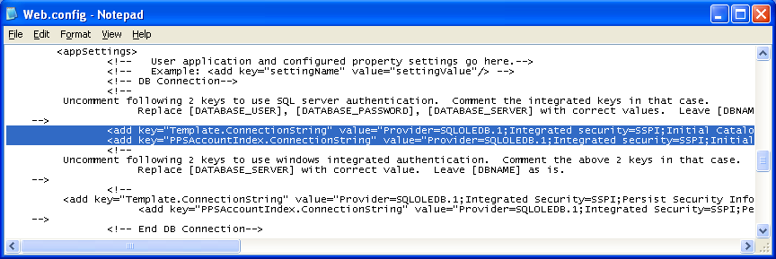
Figure 63. Web.config file — Database Server connection
To change the database hosting Office Project Portfolio Server 2007, modify the preceding lines. In the preceding example, change [DATABASESERVER] to the correct SQL Server 2005 computer.

Reporting Services connection
The Reporting Services connection is specified in four lines:
<add key="ReportServerUrl" value="http://[REPORTINGSERVER]/ReportServer/"/>
<add key="ReportServerCredentials.User" value=""/>
<add key="ReportServerCredentials.Password" value=""/>
<add key="ReportsPath" value="/Reports"/>

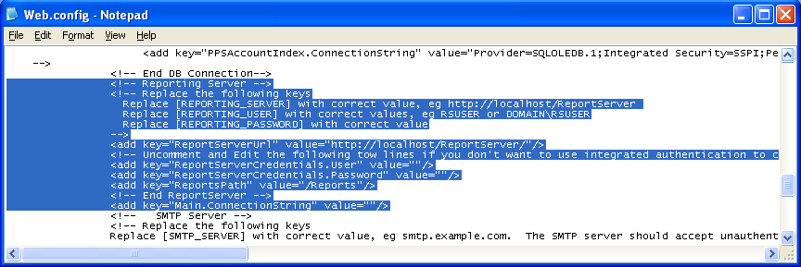
Figure 64. Web.config file — Reporting Services connection
To change the location of the reporting server, modify the appropriate lines. In the preceding example, change [REPORTINGSERVER] to the correct SQL Server Reporting Services.
When the user and password credentials are left blank (default), Office Project Portfolio Server 2007 will connect by using Integrated Windows authentication. Alternatively, you can specify a user.

SMTP Server connection
The SMTP Server connection and e-mail settings are specified in four lines:
<add key="Main.SMTPServer" value="[SMTPSERVER]"/>
<add key="Main.ApplicationPath" value="http://[PROJECTPORTFOLIOSERVER]/PortfolioServer/"/>
<add key="From" value="[EMAILFROMADDRESS]"/>

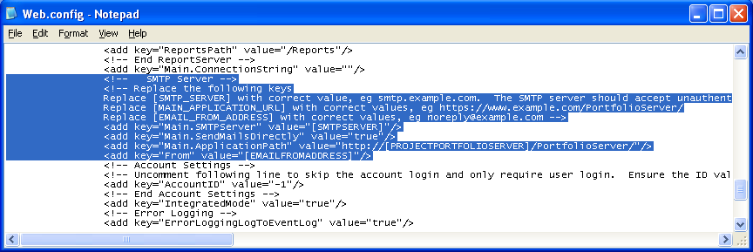
Figure 65. Web.config file — SMTP Server connection and e-mail settings
To change SMTP Server, modify the previous lines. In the preceding example, change [SMTPSERVER] to the correct SMTP server.
Note: Authentication on the SMTP server is not supported and only port 25 can be used.
The Main.ApplicationPath parameter specifies the URL in the e-mail notifications sent by Office Project Portfolio Server 2007. If the DNS name of the server or the virtual directory changed, modify this URL. In the preceding example, change [PROJECTPORTFOLIOSERVER] to the fully qualified DNS name of Office Project Portfolio Server 2007.
Note: This setting is automatically populated with the computer name by the Office Project Portfolio Server 2007 Installer.
The From key specifies the e-mail address used for sending the notifications. If you want to change this, specify the correct e-mail address. In the preceding example, replace [EMAILFROMADDRESS].

Account and Permission Requirements for Server Farm Deployment Scenarios
Security accounts and permissions must be set up properly for communication to work between the reporting server, the application server, the computer running SQL Server 2005, and, optionally, the computer running Office Project Server 2007. This section identifies the accounts used for communication between each server in the farm in both SQL authentication and Windows authentication scenarios. This section applies to deployment scenarios 1–3 in the Deployment Scenarios section of this document.

Application Server to SQL Server 2005 Computer Communication
The Office Project Portfolio Server 2007 application server and the computer running SQL Server 2005 can communicate by using either Windows authentication or SQL authentication.

Windows Authentication
When using Windows authentication, the Office Project Portfolio Server 2007 application server uses the Windows user account configured for the application pool identity to communicate with the computer running SQL Server 2005. By default, this account is typically configured as the NT Authority\Network Service account, but can be changed by using IIS Manager.
The Windows account configured for the application pool identity on the application server must have the db_datareader and db_datawriter permissions to both Office Project Portfolio Server 2007 databases.

SQL Authentication
When using SQL authentication, the Office Project Portfolio Server 2007 application server uses a SQL account to communicate with the computer running SQL Server 2005. The SQL account must have the db_datareader and db_datawriter permissions to both Office Project Portfolio Server 2007 databases.
Note: When using SQL authentication, the SQL user credentials are saved as clear text in the Web.config file. For security purposes, we strongly recommend using Windows authentication.

Application Server to Reporting Server Communication
The Office Project Portfolio Server 2007 application server and the reporting server can communicate either by using Integrated Windows authentication or by explicitly providing a specific Windows user’s credentials.

Integrated Windows Authentication
When using Integrated Windows authentication, the Office Project Portfolio Server 2007 application server uses the Windows user account configured for the application pool identity to communicate with the reporting server. By default, this account is typically configured as the NT Authority\Network Service account, but can be changed by using IIS Manager. The Windows account configured for the application pool identity on the application server must have Content Manager permission on the reporting server.

Using Provided Credentials
When explicitly provided Windows credentials, the Office Project Portfolio Server 2007 application server uses the Windows user account specified in the Web.config file to communicate with the reporting server. For more information, see the Configuring the Installation Parameters section in the Appendix of this document.
The Windows user account specified in the Web.config file for the SQL Server Reporting Services connections must have Content Manager permission on the reporting server.
Note: When using explicitly provided Windows credentials, the user credentials are saved as clear text in the Web.config file. For security purposes, we strongly recommend using Integrated Windows authentication.

Reporting Server to SQL Server 2005 Computer Communication
The Windows user account configured to run SQL Server Reporting Services on the reporting server must have the db_datareader and db_datawriter permissions to both of the Office Project Portfolio Server 2007 databases on the computer running SQL Server 2005.

Application Server to Project Server Communication
The Office Project Portfolio Server 2007 application server and the computer that runs Office Project Server 2007 can communicate by using either Integrated Windows authentication or forms authentication.

Integrated Windows Authentication
When using Integrated Windows authentication, the Office Project Portfolio Server 2007 application server uses the Windows user account configured for the application pool identity to communicate with the computer running Office Project Server 2007. By default, this account is typically configured as the NT Authority\Network Service account, but can be changed by using IIS Manager. The Windows account configured for the application pool identity on the application server must be given access to the Project Server Shared Services Provider through Central Administration. For more information, see the Office Project Server 2007 Connection (Gateway) section of this document.

Forms Authentication
When using forms authentication, the Office Project Portfolio Server 2007 application server uses the Project Server forms user-specified for a given Project Server in the Project Server Gateway settings page in the Office Project Portfolio Server 2007 interface. For more information, see the Office Project Server 2007 Connection (Gateway) section of this document.

Creating multiple accounts
An account in Office Project Portfolio Server 2007 acts like an instance of the software. Each account contains completely separate information such as the project, application, program and portfolio data, related cost and resource information, or optimization scenarios.
Multiple accounts are typically used for testing and training purposes.

Limitations
- Information cannot be shared across multiple accounts.
- In Office Project Portfolio Server 2007, Integrated Windows authentication and single sign-on for defined users can no longer be used. The user will always be prompted with a dual login: one for the Account and one for the User ID.
- Each account has to reside on the same computer running SQL Server 2005.

Recommendation
Even though multiple accounts can reside in the same database, it is recommended that you create separate databases on the same database server, one for each account. This can be done by duplicating the PPSAccountData database under a different name.

Enabling the Account Login Screen
The Office Project Portfolio Server 2007 installation wizard installs a default blank account with Account ID 1. To configure additional accounts, the first step is to configure the software to enable the Account Login screen in the Web.config file:
- Open the ProjectPortfolio2007 folder of the application (for example, C:\Inetpub\wwwroot\PortfolioServer).
Figure 66. Enabling the Account Login Screen
- Open the Web.config file. Scroll to the middle of the screen, to the “<appSettings>” section.
- Locate the accountid line and comment it out by typing <!-- before the line and --> after the line.
<!-- <add key="AccountID" value="1" /> -->

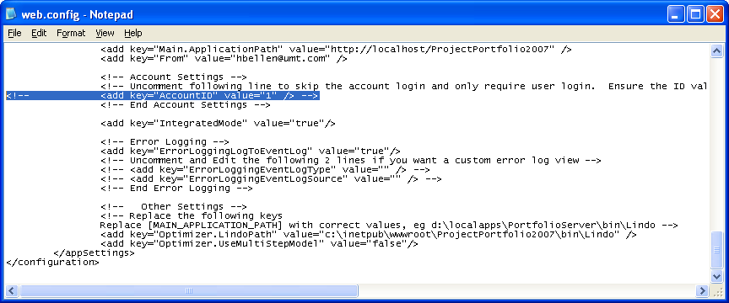
Figure 67. Web.config file — Account ID

Creating a New Account
To create a new account, you need to be logged in as the Super user in Office Project Portfolio Server 2007. During the creation of a new account, you will be asked for the database name. As suggested previously, it is recommended that you use a separate database for each account, by duplicating the default installed PPSAccountData database under a new name.

